Table of Contents
Quick Tips! 2

Getting Started 3
Where can I find my position number? 3
What approval category should I use? 3
Common EPAF Error Messages 4
I have a “Job Labor Distribution” error. What does this mean? 4
I have a “Create or Add an Hourly Job” error. What does this mean? 5
I have a “Create New Employee Record” error. What does this mean? 5
General EPAF Questions 6
Did my EPAF go through? 6
How do I know if my student has been approved to work? 6
How do I know where my student is in the hiring process? 6
How do I change my student’s rate after they have been hired? 7
How do I terminate a student? 7
What if I made a mistake after I hit “Submit?” 8
What if I don’t have access to EPAF? 8

Quick Tips!
- Position numbers should ALWAYS start with an “S”. DO NOT use the search function for position numbers, you can find it in your biweekly Payroll report.
- The suffix for each position number should ALWAYS be “00”.
- The “Query Date” should be the student’s anticipated start day.
- The only things to update on the forms are the Rate, Time Sheet Org, End Date (which must be entered twice), and any Comments. Everything else should be left alone.
- Saving does not equal submitting the form! In two separate actions, you need to click “Save” and then “Submit” in two separate functions in order for the form to submit properly.
- The student will receive an email once the EPAF is submitted. They will need to accept the position in myStetson prior Student Employment being able to hire.
- You can track your student’s hiring process through your EPAF portal! See tips below.
- You and the student will receive an automated email once the process is complete.

Getting Started

Q: Where can I find my position number?
A: The Bi-Weekly Payroll Report you receive every other Friday has the position numbers listed for the positions you supervise. It likely ends with your 4-digit organization code. If you are hiring outside your direct supervisory line, contact Student Employment.

Q: What approval category should I use?
A: A student employee can be classified as a STUD01, STUD02, or a STUD03.
STUD01 students are students that have NEVER worked on campus before. If George Washington has never held a position on campus, he would be classified as a STUD01. This also means he needs to complete federal paperwork before he can begin working.
If you’re not sure if a student has worked on campus before, you can find out when creating an EPAF. When you go to create an EPAF and pick the STUD01 category, click the “All Jobs” button to see if there are any existing jobs. If there are, the jobs will populate on the screen, and the student would not be a STUD01, but a STUD02 or STUD03. If no jobs populate when you press “All Jobs,” then the student is a STUD01.
Additionally, if you’re not sure if your student has worked before, you can find out by using the same process. When you go to create an EPAF and pick the STUD02 or STUD03 category, click the “All Jobs” button to see if there are any existing jobs. If nothing comes up, it means the student has never worked before. If a job does come up, they have worked before, and would be either a STUD02 or STUD03.
STUD02 is a student that has worked on campus before, but has not worked in this specific position. If John Smith worked in the CUB last year, but is now working in the Library, he would be a STUD02.
STUD03 is a student who has worked on campus before in the same position and is simply being rehired. If Jane Doe worked in Operations last year and is working for Operations again this year, she would be a STUD03.
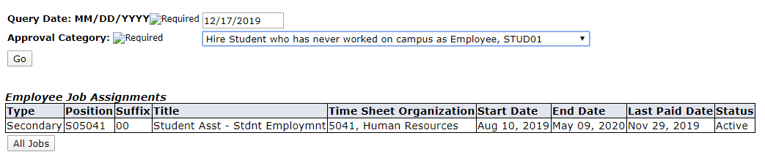

This student would NOT be a STUD01 since they have an active job that populates

Common EPAF Error Messages

Q: I have a “Job Labor Distribution” error. What does this mean?
A: This means that something within the Job Labor Distribution section is incorrect and is preventing you from submitting the EPAF form.
The “Fund,” “Organization,” “Account,” and “Program” fields in Job Labor Distribution should populate automatically, and SHOULD NOT be changed. These codes come directly from your organization.
If you have an error in this area, it is most likely because the “Effective Date” field does not match the dates located in the “Create or Add an Hourly Job” field. The dates in Job Begin Date, Job Effective Date, Personnel Date, and Effective Date in Job Labor Distribution all must match in order for the EPAF to be submitted properly.
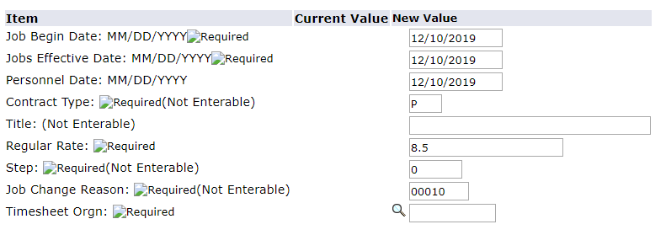

All 4 of these dates must match!

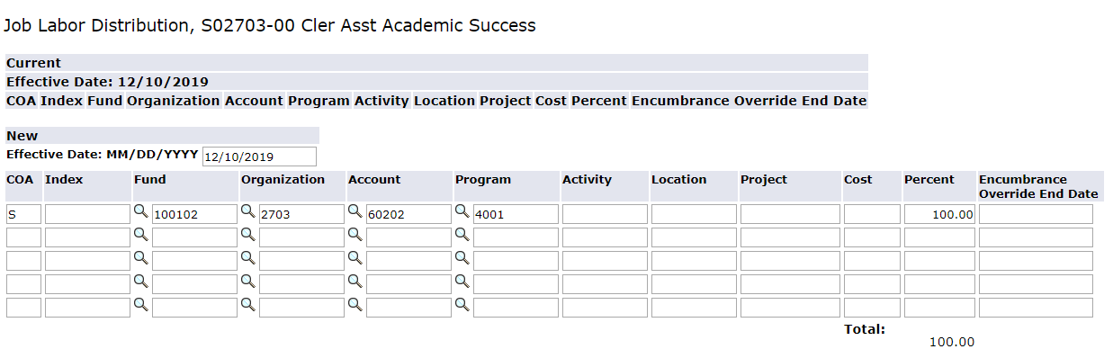

If you can’t get all the dates to match, void or delete the form and start over.

Q: I have a “Create or Add an Hourly Job” error. What does this mean?
A: This means that something within the Create or Add an Hourly Job section is incorrect and is preventing you from submitting the EPAF form.
One thing to look for is that the Job Begin Date, Job Effective Date, and Personnel Dates all must match. These dates default to the day you create the EPAF, but if you want the student to work at a future date, you can change them. However, all 3 dates must match in order for the form to work properly.
If all 3 of these dates are matching and you still have an error, it is likely because the Timesheet Origin field is not filled in. The Timesheet Origin field comes from your organization, and can be found in the “Organization” field in the Job Labor Distribution section.
These dates MUST match in order for the EPAF to submit properly!
This field needs to be completed before the EPAF can be submitted! It is simply your organization code.

Q: I have a “Create New Employee Record” error. What does this mean?
A: This is an error that typically arises when hiring international students into STUD01 positions, but can happen with domestic students as well.
These students don’t have complete records to move forward with the EPAF process and need to be updated by Student Employment. Please contact Student Employment so we can diagnose the issue. Oftentimes this triggers a process where the student will need to apply for a Social Security Card which we will assist them with.
This will likely slow down the process. Please be patient and be sure the student DOES NOT work prior to approval from Student Employment.
If you see this error, it’s okay! Contact Student Employment.
Need Section Header

General EPAF Questions

Q: Did my EPAF go through?
A: You will know if your EPAF goes through if the status reads “Pending.” In your “Current” EPAFs in the EPAF portal, it will list all of the EPAFs you have made, as well as the “Status” of all the EPAFs. In order to actually have an EPAF fully submitted, when you are done entering all of your information, you have to press the “Save” and “Submit” buttons in 2 separate actions in order for it to go through properly. Not pressing “Submit” and just “Save” will have the EPAF be in “Waiting” and not in our queue to approve for employment.
This EPAF was submitted properly! If it says “Waiting” then it was not.

Q: How do I know if my student has been approved to work?
A: A student is approved to work once Student Employment receives all the necessary info which may include I-9, W-4, position acceptance, etc. In your EPAF menu, the status will say “Complete” next to it indicating that the hiring process is over. In addition, you’ll also receive an email from Student Employment with the subject “Employment Approved for [your student name here]” to let you know that your student is ready to work.
Reminder: Students should NOT be working until you receive this email or you see the Completed status!

Q: How do I know where my student is in the hiring process?
A: You can see the status if your student by looking at the “Status” field in your list of current EPAFs. The most common statuses you will see are “Pending,” “Approved,” and “Completed.”
“Pending” means you have correctly submitted the EPAF and it is in the queue for Student Employment to look at. For STUD02 and STUD03 students, their process will be completed within 3 business days of job acceptance, but STUD01 students will not be reviewed until their I-9 and W-4 is completed AND their Job Acceptance Form is submitted.

“Approved” means Student Employment has processed the EPAF, and the hiring process will be completed within 2 business days. This status means that Student Employment has checked the EPAF for errors and has found none, and has moved the process along to the next step. If there are errors, however, you will be contacted by Student Employment, and your EPAF will not move on to this step until the errors are fixed. If your form has “Approved” status for more than 2 business days, contact Student Employment.

“Completed” means the student’s hiring process is complete. In this stage, you will receive an email from Student Employment with the subject “Employment Approved for [your student name here]” meaning your student can begin work immediately!

Q: How do I change my student’s rate after they have been hired?
A: Simply email Student Employment (studentemployment@stetson.edu) and include the name and ID number of the student you wish to change the rate of, as well as the new rate and position number.
For example, if I want to give John Smith a raise from $8.50/hour to $9/hour, I would email Student Employment the following:
- Name: John Smith
- ID: 8001234567
- New Rate: $9/hour
- Position #: S04029

Q: How do I terminate a student?
A: To terminate a student, please visit our website’s “Forms and Materials” page (https://www.stetson.edu/other/student-employment/forms-and-materials.php), and complete the “Off-Boarding Form.” This form gets submitted directly to Student Employment and will be processed within 3 business days.

Q: What if I made a mistake after I hit “Submit?”
A: If your EPAF is “Pending” and you made a mistake, you can change anything EXCEPT the position number, student type (STUD01, STUD02, STUD03), and start date. These fields are locked in once the form is submitted, so if these mistakes are made, please “Delete” or “Void” the form and start over.

Q: What if I don’t have access to EPAF?
A: Email Student Employment (studentemployment@stetson.edu) and we will work on getting you access. It can take a bit of time, so please be patient.

