CALL FOR PROPOSALS:
Willa Dean Lowery Grants to Support Research
in the Natural Sciences at Stetson University
for
Funding Cycle 2023-2024
The core focus of Stetson University’s mission is learning, and the priority is the creation of a stimulating, inclusive learning community. Stetson’s faculty members inspire and model a commitment to lifelong learning through the Teacher-Scholar role. The Willa Dean Lowery Grant advances the teacher-scholar role by encouraging proposals for innovation in natural sciences research. The fund is made possible through the generosity of Dr. Willa Dean Lowery ’48, whose exceptional career ranged from bacteriologist, obstetrician and gynecologist to public health officer and theologian. Her patronage and pioneering vision has been critical in boosting Stetson’s footprint in the natural sciences. Through her support of the natural sciences, Stetson University has bestowed Lowery Grants for meritorious scientific research projects, several of which have garnered national recognition.

Proposals are invited for natural science projects that show promise and contribute to the faculty member’s development as a teacher-scholar. Funding is based on the quality of the proposal (see Review Criteria) and the potential contribution to the tenured/tenure-track faculty member’s teacher-scholar agenda, to the culture of research we wish to establish for undergraduates, and to the College of Arts and Science’s wider recognition for excellence in science. Faculty may propose new projects, work that builds on or anticipates a sabbatical project, strengthens summer grant research, and more. Faculty on sabbatical may apply. Proposals that include undergraduate researchers are strongly encouraged as are proposals that involve collaboration among Stetson faculty in scientific disciplines. Requests for funding for chemicals, research materials and supplies, or instrumentation are appropriate. Proposers may also request summer stipends. Requests for support for a course reassignment/reconfiguration is allowed and will require a compelling presentation of the plan for meeting research goals and supporting the Natural Sciences Division’s teaching obligations in major or General Education courses. In short, awards support what best advances scientific research at Stetson University.

PROPOSALS SHOULD INCLUDE THE FOLLOWING:
- Cover Page. See below.
- Abstract. The abstract should briefly describe the purpose of the project, the overall objective, project plans, anticipated results, and the potential impact. (200 word maximum)
- Project Description. Provide a brief project description (no more than two pages). Include the following:
- Innovation: Describe the innovative features of the project and/or identified need related to the scope of the discipline. Provide specific and clear evidence of this innovation and/or need. Describe any background or context that non-disciplinary reviewers will need to understand your project.
- Goals: Clearly list the project goals and anticipated outcomes.
- Potential for deep impact. Explain the impact (breadth/depth) this project will have on the mission and strategic goals of Stetson University; on the program/department/curriculum such as research with students; and on the disciplinary/interdisciplinary field(s).
- Project Activities. Describe specific activities, responsible parties and why these parties are necessary for the success of the project, and the timeline related to the goals. Include descriptions of any products (publications, presentations, scholarly artifacts, materials, workshops, courses, etc.) that will result.
- Measurement of Project Impact. The proposal must include a plan for examining the impact of the project. This might include some type of assessment design to benchmark gains towards desired scientific outcomes and Stetson University’s strategic goals.
- Dissemination Plan. Describe how/when you plan to disseminate the results of your project including presentations at professional conferences, publications, and plans to share with the Stetson community.
- Project Sustainability Plan. Describe how you plan to sustain/institutionalize the successful ideas learned from your project. For example, how will you encourage adoption/broader participation at Stetson using these best research practices?
- Budget tied to goals. Use a separate page to provide a budget with brief explanations (justification) of how each request will further the project goals. Describe other sources of funding (summer grant, external grant, etc.) for this project.
- Curriculum Vitae. Attach to the proposal application. (2 pages maximum)

FUNDING
Grants are available for up to $10,000 per project. Proposal requests can range from a minimum of $2,000 up to $10,000 per project. Given the timeframe of the scientific research process, projects may span the full 15-month funding period (see Funding Cycle and Deadlines).

FUNDING CYCLE AND DEADLINES
The deadline for proposal submission is February 1, 2023, for the 2023-2024 funding cycle. Proposals submitted after the deadline will not be considered. Awards will be announced by February 28, 2023.
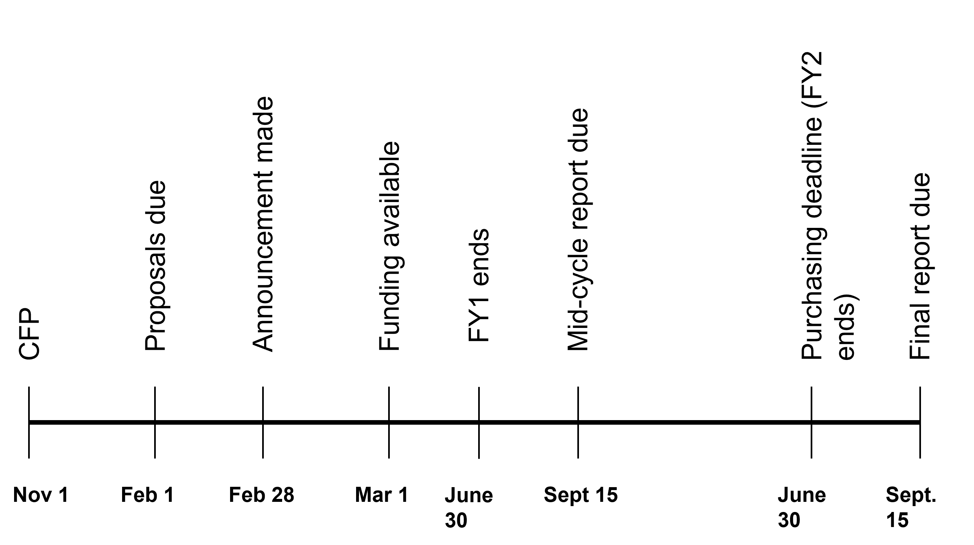
Nov 1, 2022 Call for Proposals
Feb 1, 2023 Proposals due
Feb 28, 2023 Awards announced
Mar 1, 2023 Funding Cycle begins
Sept 15, 2023 Progress report due
Jun 30, 2024 Expenditure deadline
Sept 15, 2024 Final report due

REVIEW CRITERIA
Each proposal is rated using the criteria listed below.
Criteria | Possible Points
Abstract clearly demonstrates the purpose of the project, the overarching goal, the project plan, anticipated results, and potential impact | 5
Innovation is novel and challenging | 10
Goals demonstrate potential for significant advancement in science/science education/student research | 15
Project plan demonstrates compelling need and appropriate timeline | 25
Study is well designed and demonstrates methodology appropriate for project implementation | 25
Realistic plan for disseminating result is tied to anticipated project outcomes | 5
Plan for sustaining project is feasible and appropriate | 5
Budget expenditures are reasonable, justified, and directly aligned with the proposal plan | 10
TOTAL POSSIBLE POINTS | 100

SUBMISSION INSTRUCTIONS
1. Complete online application (Opens November 1).
2. Complete abstract on application.
3. Attach the 2-page proposal (12pt type).
4. Attach a budget that includes justification for each request; include description of other funding.
5. Attach your curriculum vitae (2 pages maximum).
6. Submit items MSWord (.doc or .docx) or Adobe Acrobat (.pdf) format attachment
7. Submit on/before February 1, 2023.

A committee will be selected by the dean to consider applications; the secretary of the Natural Sciences Division will chair, and the dean and associate provost for Faculty Development will serve as ex officio members. Successful applications will receive notification by February 28 pending approval by the provost. Applications not selected for awards will receive response to help in strengthening for re-submission. A progress project report from successful award recipients is due on/before September 15 and final report by September 15 of the subsequent year. Questions should be directed to Associate.Provost@stetson.edu.
REPORTING
Each successful project investigator will be required to submit a progress and a final report.
September 15, 2023 Progress Report (with abstract): Submit to Dean’s Office of the College of Arts and Sciences. Submit a copy of the progress report to Associate.Provost@stetson.edu.
September 15, 2024 Final Report (with abstract): Submit the report online at the Reporting Form. Final project reports will be stored on a secure server at the duPont-Ball Library.

Progress Report Guidelines
- Project Title and Grant Recipient(s)
- Abstract: Original or amended
- Progress to achieving your goals: A summary describing progress toward meeting each goal.

Final Report Guidelines
- Project Title and Recipient(s)

- Goals and progress to achieving your goals: The extent to which each goal was met, achieved or not; evidence to support progress to goal or the level of attainment/achievement of the goal; include artifacts.

- Changes: Any changes you made to the proposed work and the change in impact/outcome; what might have surprised you (that is, did not anticipate), etc.

- Impact: Describe the impact of the work and provide artifacts as supporting evidence:
- The discipline, field of study, interdisciplinary, cross-disciplinary area
- The institution (alignment to Stetson's mission, values, and strategic goals)
- The department/college or school/university
- Students (teaching and learning, skill/ability/disposition development, etc.)
- Your own professional development as a Stetson Teacher-Scholar
- Student Engagement: If applicable,
- Indicate the number of students involved
- Describe the primary learning goal and their inquiry engagement
- Describe the impact of this project on increasing students’ ability to (choose one, more or other) think critically; and/or solve a problem; and/or integrate learning; and/or other desired skill, ability, disposition.
- Plan for Sustainability: Describe how you plan to sustain the project.
  - Creating/strengthening internal/external professional partnerships and networks/collaborations
  - Developing scientific and/or scholarly dispositions of others to advance this work
  - Integration in course work, course design or re-design
  - Development of new scientific initiatives or strengthening existing initiatives.
- Plan for Seeking Extramural Funding: Describe your plan for seeking external funding or other support. Include any sources of potential funding or other support; and describe assistance you would need in pursuing these sources.

- Acknowledgements: Provide professional acknowledgements including the Willa Dean Lowery Grant.

Willa Dean Lowery Grant
Proposal Submission Deadline: February 1, 2023

Application Form: Online
Applications will be accepted online only
Maximum funding for any single grant: $10,000; Minimum funding: $2,000
Proposal must be limited to two pages plus a budget page in addition to the single page cover sheet and CV.

Requested Online Information

- Project Investigator Name

- Department

- Email Address

- Collaborator(s) & Affiliation

- Project Title

- Abstract (200-word maximum):

- Budget Requested ($2,000 minimum /$10,000 maximum)

- In a sentence or two, how does this project honor Dr. Lowery’s legacy as a scientist and health professional?

- As a Willa Dean Lowery researcher, I/we acknowledge that I/we must submit written reports to the dean of the College of Arts and Sciences (and copied to Associate.Provost@stetson.edu) on/before the deadlines. I/We acknowledge that reports will be shared with the fund benefactor of the estate of Dr. Willa Dean Lowery and will be used in other reports.

- Uploads (submit separately or as one document):

- 2-page proposal (12pt type)
- Budget that includes justification for each request; include description of other funding
- Curriculum vitae (2 pages maximum)

