CALL FOR PROPOSALS:
Willa Dean Lowery Fund to Support Research
in the Natural Sciences at Stetson University
for
Funding Cycle 2017-2018

The core focus of Stetson University’s mission is learning and the priority is the creation of a stimulating, inclusive learning community that encourages a lifelong commitment to learning. Stetson’s faculty members inspire and model this commitment through the Teacher-Scholar Role role. The teacher-scholar model emphasizes the integration of the faculty role as educator, scholar, citizen, and leader, as expressed by Boyer’s pivotal work, Scholarship Reconsidered: Priorities of the professoriate. The Willa Dean Lowery Fund to support faculty research in the Natural Sciences advances the teacher-scholar role at Stetson University by encouraging proposals for innovation in scientific research.

Proposals are invited for natural science projects that show promise and contribute to the faculty member’s development as a teacher-scholar. Funding will be awarded on the basis of the quality of the proposal and the potential contribution to the tenured or tenure-track faculty member’s teacher-scholar agenda, to the culture of research we wish to establish for undergraduates, and to the College of Arts and Science’s wider recognition for excellence in science.

Faculty may propose new projects, work that builds on or anticipates a sabbatical project, strengthens summer grant research, and more. Faculty on sabbatical may apply. Proposals that include undergraduate researchers are strongly encouraged, as are proposals that involve collaboration among Stetson faculty in scientific and non-scientific disciplines. Requests for funding for chemicals, research materials and supplies, or instrumentation are appropriate. Proposals may also request summer stipends. Requests for support for a course reassignment/reconfiguration will be allowed, but will require a compelling presentation of the plan for meeting research goals and supporting the Division’s teaching obligations in major or General Education courses. In short, the Fund seeks whatever best advances scientific research at Stetson University.

PROPOSALS SHOULD INCLUDE THE FOLLOWING:
- Abstract. The abstract should briefly describe the purpose of the project, the overall objective, project plans, anticipated results, and the potential impact. (200 word maximum)
- Project Description. Write a brief description (no more than two pages). Include the following:
- Innovation: Describe the innovative features of the project and/or intellectual merit and/or identified need related to the scope of the discipline. Provide specific and clear evidence of this innovation, intellectual merit, and/or need. Describe any background or context that non-disciplinary reviewers will need to understand your project.
- Goals: Clearly list and explain the project goals.
- Potential for deep impact. Explain breadth/depth of impact this project will have on the mission and strategic goals of Stetson University; on the program/department/curriculum such as research with students; and on the disciplinary field(s); and your development as a teacher-scholar.
- Project Activities. Describe specific activities, responsible parties and why these parties are necessary for the success of the project, and the timeline related to the goals. Include descriptions of any products (publications, presentations, scholarly artifacts, workshops, etc.) that will result.
- Measurement of Project Impact. The proposal must include a plan for examining the impact of the project. This might include some type of assessment design to benchmark gains towards desired scientific outcomes and Stetson University’s strategic goals.
- Dissemination Plan. Describe how/when you plan to disseminate the results of your project including presentations at professional conferences, publications, as well as plans to share your outcomes with the Stetson community.
- Project Sustainability Plan. Describe how you plan to sustain/institutionalize the successful ideas that have been learned from your project or support the project beyond the funding cycle. For example, how will you encourage adoption/broader participation at Stetson using these best research practices?
- Budget tied to goals. Use a separate page to provide a budget with brief explanations (justification) of how each request will further the project goals. Describe other sources of funding (summer grant, external grant, etc.) for this project.
- Curriculum Vitae. Please attach to the proposal application. (2 pages maximum)
FUNDING
The Fund will distribute $10,000 to a project or projects selected for support. Requests can range from a minimum of $2,000 to the full $10,000. Given the timeframe of the scientific research process, project s may span the full 16-month funding period (see Funding Cycle).

FUNDING CYCLE AND DEADLINES
The deadline for proposal submission is February 1, 2017 for the 2017-2018 funding cycle. Proposals submitted after deadline will not be considered. Awards will be announced by February 28, 2017.
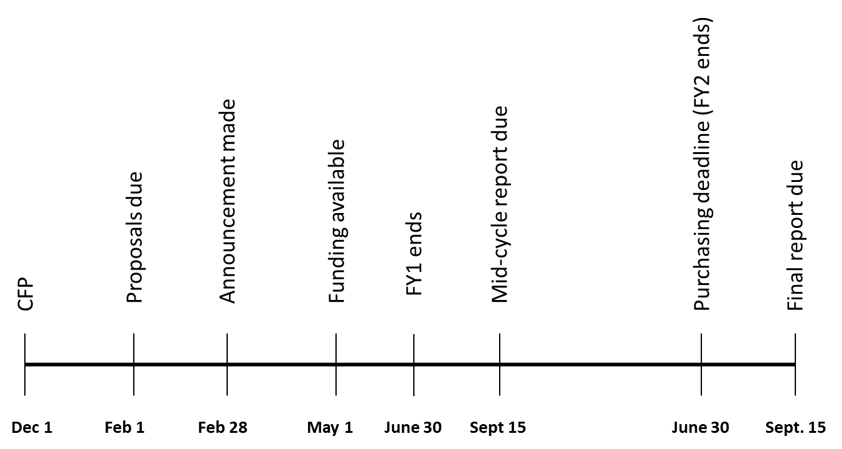
December 5, 2016: Deadline to announce Call for Proposals
February 1, 2017: Proposals due
February 28, 2017: Awards announcement due
May 1, 2017: Funding Cycle begins
September 15, 2017: Mid-cycle report due
June 30, 2018: Expenditure deadline
September 15, 2018: Final report due

REVIEW CRITERIA
Each proposal will be rated using the criteria listed below.
Criteria | Possible Points
Abstract briefly describes the purpose of the project, the overarching goal, project plans, anticipated results, and potential impact | 5
Innovation described is novel and challenging; identified need for project is compelling | 10
Goals are significant and relate to advancement in science/science education/student research | 20
Project plan is compelling, based on identified need, and appropriate timeline | 20
Study is well designed and describes appropriate methodology for project implementation | 25
Realistic plan for disseminating result is tied to anticipated project outcomes | 5
Plan for sustaining project is suitable | 5
Budget expenditures are reasonable, justified, and directly linked to proposed plan | 10
Total Possible Points | 100

SUBMISSION INSTRUCTIONS
1. Complete cover sheet (found on the following page).
2. Complete abstract on cover page.
3. Attach the 2-page proposal (single-spaced, one-inch margins, 12pt type).
4. Attach 1-page budget which includes justification for each request; include description of other funding.
5. Attach your curriculum vitae (2 pages maximum)
6. Submit items 1-5 in a single MSWord (.doc or docx) or Adobe Acrobat (.pdf) format attachment as LastName_WDL17-18.doc (or.docx or .pdf or other Word Processing format)
7. Submit to PDC@stetson.edu on/before February 1, 2017.

Applications should be directed to the Professional Development Committee at PDC@stetson.edu. A committee will be selected by the Dean to consider applications; the secretary of the Natural Sciences Division will chair, and the Dean and Associate Provost for Faculty Development will serve as ex officio members. The deadline for submission is February 1, 2017. Successful applications will receive notification by February 28, 2017. Applications that are not selected for awards will receive response to help in strengthening for re-submission. A project report is due on/before September 15, 2018 from successful award recipients. Questions should be directed to BrownCenter@stetson.edu.

REPORTING
Each successful project investigator will be required to submit a project report (with abstract) on/before September 15, 2018 to Dean’s Office, College of Arts and Sciences. Submit a copy of the report to BrownCenter@stetson.edu. Project reports will be stored on a secure server at the duPont-Ball Library.

Reporting Guidelines
- Project Title and Grantee(s)
- Goals and progress to achieving your goals: The extent to which each goal was met, achieved or not; evidence to support progress to goal or the level of attainment/achievement of the goal; include artifacts.
- Changes: Any changes you made to the proposed work and the change in impact/outcome; what might have surprised you (that is, did not anticipate), etc.
- Impact: Provide evidence of impact of the work on the following. Provide supporting artifacts as evidence.
- the discipline, field of study, interdisciplinary, cross-disciplinarily area)
- the institution (alignment to Stetson's mission, values, and strategic goals)
- the department/college or school/university
- students (teaching and learning, skill/ability/disposition development, etc.)
- your own professional development as a Stetson Teacher-Scholar
- Student Engagement: If applicable,
- indicate the number of students involved
- describe the primary learning goal and their inquiry engagement
- describe the impact of this project on increasing the student’s(’) ability to (choose one, more or other) think critically; and/or solve a problem ; and/or integrate learning; and/or other desired skill, ability, disposition
- Plan for sustainability: describe how you plan to sustain the project.
  - creating/strengthening internal/external professional partnerships and networks/collaborations
  - developing scientific and/or scholarly dispositions of others to advance this work
  - integration in course work, course design or re-design
  - development of new scientific initiatives or strengthening existing initiatives.
- Plan for seeking extramural funding: describe your plan for seeking external funding or other support. Include any sources of potential funding or other support; and describe assistance you would need in pursuing these sources.
- Acknowledgements: Provide any professional acknowledgements including Willa Dean Lowery Fund.

Willa Dean Lowery Fund
Application Cover Sheet
Proposal Submission Deadline: February 1, 2017

Maximum funding for any single grant: $10,000.
Proposal must be limited to two pages plus a budget page in addition to the single page cover sheet and CV.

Project Investigator Name: __________________________________________________________________
Department: ____________________________________ Email Address: ________________________

Collaborator(s) Affiliation
_______________________________________________ ____________________________________
_______________________________________________ ____________________________________
_______________________________________________ ____________________________________

Project Title: _____________________________________________________________________________
________________________________________________________________________________________

Abstract (200-word maximum):

Budget Requested ($2,000 minimum /$10,000 maximum): ___________________

In a sentence or two, why do you think your project would impress Dr. Lowery as an example of Stetson research? ________________________________________________________________________________
___________________________________________________________________________________________________________________________________________________________________________________________________________________________________________________________________________

I/we acknowledge that I/we must submit a written report to the Dean, College of Arts and Sciences and on work as a Willa Dean Lowery researcher on/before September 15, 2018. This report will be shared with the fund benefactor, Dr. Willa Dean Lowery. Submit a copy of the report to BrownCenter@stetson.edu.

Signed: ________________________________________ Date: _______________
Signed: ________________________________________ Date: _______________
Signed: ________________________________________ Date: _______________

