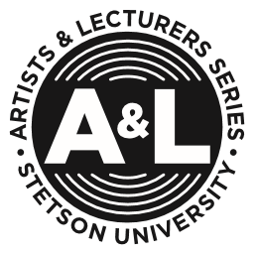

Artists & Lecturers Series Event Report

Event:

Date:

Venue:

A&L Funding Received:

Additional Sources of Funding:

Attendance:

Promotional Efforts:

Press Coverage:

Eligible for Cultural Credit: Yes ______ No ______

