STETSON UNIVERSITY - 2022 |  | 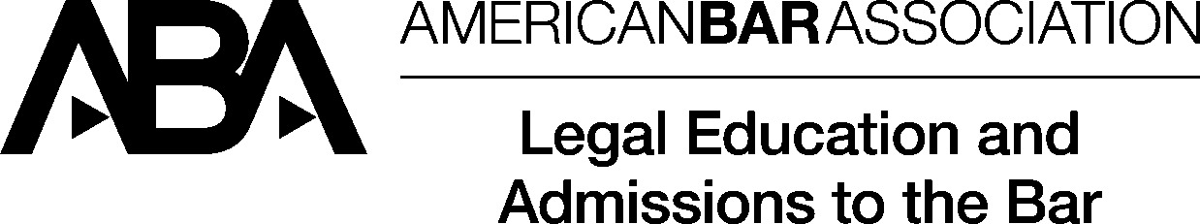
  1401 61st Street South
  Phone 727-562-7800
  Website : http://www.law.stetson.edu

Ultimate Bar Passage

 | A | B |  |  | C |  |  | D |  | D | E
Calendar Year of graduation | Number of graduates in calendar year | Graduates who sat for a bar examination within one year of their date of graduation. |  |  | Graduates who sat for a bar examination within two years of their date of graduation. |  |  | Graduates who have been admitted or have applications pending to be admitted via Diploma Privilege |  | Number with no information | Number who did not take a bar examination
 |  | # of takers | # who passed | % that passed | # of takers | # who passed | % that passed | # of Diploma Privilege | % that passed (incl. Diploma Privilege) |  | within one years of graduation | within two years of graduation
2019 | 245 | - | - | - | 229 | 209 | 91.27% | 0 | 91.27% | 0 | - | 16

First Time Bar Passage
 | A | B | C | D | E | F | G | H | I | J | K
Calendar Year | Total Graduates in Calendar Year* | # from Calendar Year NOT taking Bar Exam | # from Previous Years Taking Bar for First Time in Calendar Year | Number of Early Takers | # from Calendar Year with no information | Total First Time Takers in any jurisdiction | Total who passed the bar in any jurisdiction | Law School weighted average pass rate | ABA first time weighted average pass rate | Difference In Weighted Average | Graduates who have been admitted or have applications pending to be admitted via diploma privilege
2021 | 269 | 64 | 46 | 1 | 0 | 252 | 192 | 76.19% | 70.25% | 5.94% |  | 76.19%

Details 2021:
Jurisdiction | Takers | Passers | Pass % | State Pass % for ABA approved law schools | Difference
FLORIDA | 228 | 173 | 75.88 | 69.61 | 6.27
16 REMAINING JURISDICTION | 24 | 19 | 79.17 | 75.09 | 4.08

