Team No. 118

**Docket No. 2024-CR-319**

**IN THE**

**SUPERIOR COURT OF THE STATE OF STETSON**

**PINELLA COUNTY JUDICIAL DISTRICT**

**State of Stetson**

v.

**Jay Cameron,**

*Defendant.*

**MOVANT’S MEMORANDUM OF LAW IN SUPPORT OF DEFENDANT’S MOTION TO DISMISS**



# Table of Contents

Table of Contents i

Table of Authorities iii

Introduction 1

Statement of Facts 1

I. Jay Cameron rents a room at the Boals Motel, expecting to spend the day hanging out with his brother, Greg. 1

II. As Jay and Greg are leaving to get breakfast, Wilson initiates a verbal altercation with Jay. 2

III. After Jay and Greg leave the premises, Wilson retrieves a black object resembling a gun. 2

IV. While returning from breakfast, Jay attempts to steer clear of Wilson’s path and warns him that he could defend himself if needed. 3

V. Wilson follows Jay into a breezeway and shoots at him, forcing Jay to defend himself. 4

Standard of Review 5

Argument 7

I. Jay Cameron is entitled to immunity because he was not participating in criminal activity by carrying a gun before Wilson attacked him. 7

A. Jay’s gun, carried to protect himself from Wilson, was in ordinary sight. 8

B. Jay alerted Wilson to the presence of his gun. 9

II. Jay Cameron is entitled to immunity because he was not an aggressor in Wilson’s attack on him. 10

A. Jay did not provoke Wilson to use force. 10

B. Jay’s acts of self-defense against Wilson were justified under § 776.041. 13

1. Jay was not an aggressor under § 776.041(1), as he was not committing a “forcible felony” before Wilson commenced his attack. 13

2. Regardless of who was the initial aggressor, Jay was justified in defending himself against Wilson under § 776.041(2)(a). 14

a. Jay’s belief that Wilson posed a threat of death or bodily harm to him was reasonable. 14

b. Wilson’s danger to Jay was imminent. 17

c. Jay could not escape Wilson’s gunshots without using self-defense. 17

Conclusion 18

# Table of Authorities

**Stetson Statutes Page(s)**

Stet. Stat. § 3.190(b) ...................................................................................................... 5

Stet. Stat. § 776.012 ................................................................................... 1, 5, 7, 10, 14

Stet. Stat. § 776.032 ....................................................................................... 5, 7, 10, 18

Stet. Stat. § 776.041(1) .................................................................................... 13, 14, 18

Stet. Stat. § 776.041(2) ........................................................................ 10, 13, 14, 17, 18

Stet. Stat. § 777.04 ............................................................................................. 5, 13, 18

Stet. Stat. § 782.04 ............................................................................................. 5, 13, 18

Stet. Stat. § 790.01(2) .................................................................................... 5, 7, 10, 18

**Statutes from Other Jurisdictions**

Ind. Code § 35-41-3-2 (2024) ........................................................................................... 6

Fla. Stat. § 776.08 (1995) ............................................................................................. 13

N.H. Rev. Stat. Ann. § 627:4 (2011) .............................................................................. 6

Tex. Penal Code § 9.32 (2007) ....................................................................................... 6

Wyo. Stat. Ann. §6-2-602 (2018) ................................................................................... 6

**Supreme Court Cases**

*Hoffman Estates v. Flipside, Hoffman Estates*, 455 U.S. 489 (1982) ................................ 7

*Intel Corp. Inv. Policy Comm. v. Sulyma*, 589 U.S. 178 (2020) ........................................ 9

*Ohio v. Akron Ctr. for Reproductive Health*, 497 U.S. 502 (1990) ................................... 6

*Regalado Cuellar v. United States*, 553 U.S. 550 (2008) .............................................. 7, 8

**Other Cases Pages**

*Airsman v. Airsman*, 179 So. 3d 342 (Fla. Dist. Ct. App. 2015) ....................................... 6

*Bouie v. State*, 292 So. 3d 471 (Fla. Dist. Ct. App. 2020) ........................................... 6, 15

*Dorelus v. State*, 747 So. 2d 368 (Fla. 1999) ................................................................. 7, 8

*Edwards v. State*, 351 So. 3d 1142 (Fla. Dist. Ct. App. 2022) .......................................... 6

*Ensor v. State*, 403 So. 2d 349 (Fla. 1981) ........................................................................ 8

*Gibbs v. State*, 789 So. 2d 443 (Fla. Dist. Ct. App. 2001) ............................................... 11

*Little v. State*, 302 So. 3d 396 (Fla. Dist. Ct. App. 2020) ................................................ 11

*McCullough v. State*, 327 So. 3d (Fla. Dist. Ct. App. 2021) ........................................... 13

*Pflaum v. State*, 879 So. 2d 93 (Fla. Dist. Ct. App. 2004) ............................................... 17

*Reed v. State*, 287 So. 3d 606 (Fla. Dist. Ct. App. 2019) ................................................ 11

*Slomowitz v. Walker*, 429 So. 2d 797 (Fla. Dist. Ct. App. 1983) ...................................... 6

*Smith v. State*, 387 So. 3d 495 (Fla. Dist. Ct. App. 2024) ............................................... 17

*State v. Quevedo*, 357 So. 3d 1249 (Fla. Dist. Ct. App. 2023) ........................................ 15

# Introduction

This Court should grant Jay Cameron (“Jay”)’s Motion to Dismiss because Jay was entitled to stand his ground against his attacker, Ryan Wilson (“Wilson”). Jay is entitled to immunity from prosecution as he was properly using self-defense under Stet. Stat. § 776.012.

Wilson initiated an argument with Jay, followed him from behind into a breezeway, and shot at him from around the corner of it, forcing Jay to fire back in self-defense. Jay is entitled to immunity for his shots back at Wilson because he was properly using self-defense under § 776.012.

# Statement of Facts

## Jay Cameron rents a room at the Boals Motel, expecting to spend the day hanging out with his brother, Greg.

On August 5th, 2022, Jay Cameron, a 24-year-old Stetson resident, rented Room 1077 at the Boals Motel (“the motel”). R. at 12, 18. Around 9AM on August 6th, Jay called his brother, Greg Cameron, to ask if he wanted to hang out. R. at 19, 29. The two had hung out there a few times before. R. at 29. Greg arrived at around 9:30AM. *Id*.

Due to persistent struggles with finding permanent housing, Jay was a frequent guest of the motel, which he described as “clean” and “cheap.” R. at 19. Jay knew that the motel’s safety, though, was often in question due to an individual named Ryan Wilson, who Jay personally knew to be “violent” because he “had been threatening everyone at the Boals Motel for months.” R. at 19, 20. Wilson was usually around at the motel and “always knows who’s coming and going.” R. at 45. Despite knowledge of Wilson’s disturbances, Jay continued to stay at the motel, trusting that if he had “strength in numbers” – another person with him – he could expect to be safe from Wilson. R. at 19. Because he faced housing insecurity, Jay knew very well that the Stetson streets are “tough” and typically carried a gun with him in case he ever needed to use self-defense. R. at 20, 31.

Jay had been wary of Wilson’s violent tendencies for quite some time and was “sick of” them so he always did his best to avoid crossing paths with Wilson as he does not believe in violence. R. at 20, 31. Jay wanted his community to be able to live freely from fear of Wilson but has never taken action against Wilson. *Id*.

## As Jay and Greg are leaving to get breakfast, Wilson initiates a verbal altercation with Jay.

Shortly after 9:30AM, the Cameron brothers left the motel to get breakfast. R. at 20. As the brothers left Room 1077 to walk to a nearby diner, Wilson began taunting Jay. *Id*. As Jay crossed in front of Wilson, Wilson exclaimed, “Keep your distance, or else.” *Id*. Jay asked Wilson who he was talking to, to which Wilson responded, “Who else? You’re a dead man walking.” *Id*. Jay was “shook” by this and knew he’d have to defend himself if Wilson ever came at him. *Id*.

Wilson alleges, alternatively, that Jay started the verbal taunting. R. at 57.

## After Jay and Greg leave the premises, Wilson retrieves a black object resembling a gun.

After Jay and Greg left, Wilson went into his room, without telling Kenny Gray (“Gray”), who was there with him, why he suddenly got up to go into the room. R. at 46. When Wilson returned from the room, Gray saw Wilson shoving a “black object” into his pocket. *Id*. Wilson stated that the object was his cell phone. R. at 57. Gray believed it “looked like a gun,” though, because he “knows what it looks like when someone’s packing.” R. at 46, 47. Gray also noticed that Wilson looked angry when he left the room. R. at 46. Gray saw Wilson spit on the ground, shake his head, and say, “Let him try. Everyone knows this is my turf.” *Id*.

## While returning from breakfast, Jay attempts to steer clear of Wilson’s path and warns him that he could defend himself if needed.

When the brothers returned from breakfast, Greg noticed Wilson watching Jay “like a hawk,” while holding what appeared to be a gun. R. at 33. Jay’s mission was to stay out of Wilson’s way because he “didn’t want to deal with him.” R. at 20. To do this, Jay kept his hood up and walked quickly. R. at 21. Jay walked through the parking lot to reach the motel breezeway rather than walking on the sidewalk directly in front of Wilson’s room. R. at 16. Jay then used his left hand to make the shape of a gun and verbally said “pop pop” so that Wilson “would know I was armed and not to mess with me.” R. at 21. Jay kept his right hand in his hoodie pocket, where his large .40 caliber gun was. *Id*. Gray was able to easily recognize it to be a gun. R. at 47.

After making the “pop pop” statement, Jay continued to make his wide arc around Wilson to get into the breezeway:

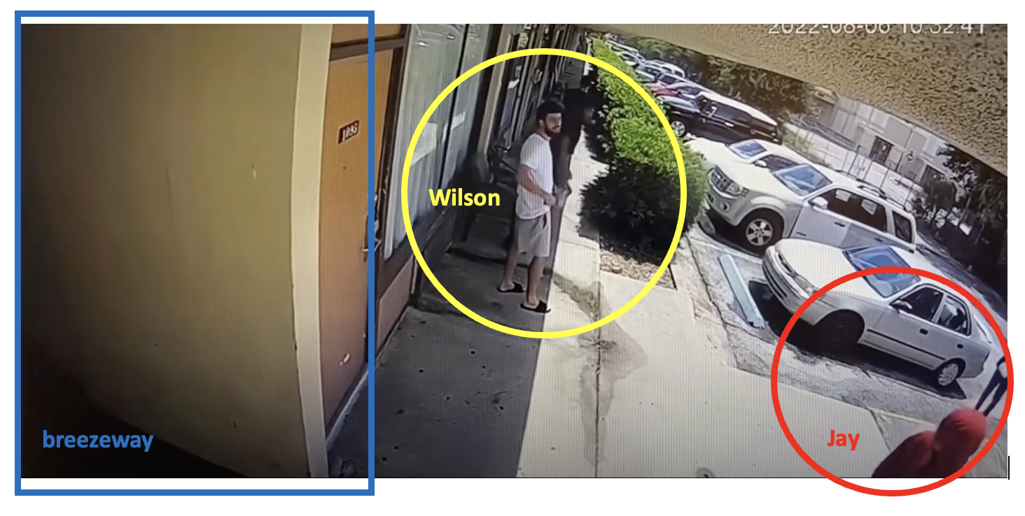

R. at 16 (0:07) (emphasis added). While doing so, he saw Wilson pull a black object resembling a gun out of his pocket. R. at 22. Jay knew it to be a gun by the way Wilson was holding it. *Id*. Jay then heard one of Wilson’s friends say “he’s done.” *Id*.

Wilson alleges that Jay made a threat to kill him at this point by making “a quick sliding motion with his thumb across his neck.” R. at 60. Wilson is the only witness who has testified to this occurring.

## Wilson follows Jay into a breezeway and shoots at him, forcing Jay to defend himself.

As Jay turned the corner into the breezeway, Greg stayed behind in the parking lot. R. at 33. Greg then saw Wilson follow Jay into the breezeway with his gun drawn, “stalking him with his gun out like prey to be killed.” R. at 34, 35. Greg then yelled, “Yo watch out man!” to Jay. R. at 34. Jay heeded the warning, turned around, and drew his gun. Surveillance video shows Wilson turning the corner into the breezeway and firing the first shot. R. at 16.

Jay shot back at Wilson a few times “in defense of his own life.” R. at 36. Jay was shot in his stomach and subsequently shot Wilson in his left shoulder. R. at 23. Wilson began to stumble backwards, but his gun was still pointed at Jay. *Id*. Only when Jay shot Wilson in the back did Wilson become separated from his gun. *Id*. Jay yelled for Greg to come get the gun so that Wilson could not grab it again. *Id*. Then, the brothers ran away, putting both guns in Room 1077 out of fear that having guns on them would hinder Jay’s ability to get medical treatment. R. at 24. Nervous that Wilson’s crew would come to the hospital to retaliate, Greg chose to drive Jay to a farther away hospital. R. at 38.

Jay has been charged with Attempted Murder in the Second Degree and Carrying a Concealed Weapon in alleged violations of Stetson General Statutes § 782.04, § 777.04, and § 790.01(2). R. at 67.

# Standard of Review

If an individual reasonably believes that using deadly force is necessary to prevent death or great bodily harm to himself, he is justified, under the law, in using that force. § 776.012. An individual using such force has no duty to retreat, provided that he is not engaged in a criminal activity, is in a place where he has a right to be, and is not the aggressor. § 776.012. This statute is known as the Stand Your Ground [“SYG”] statute. A person who uses the force permitted under § 776.012 is immune from criminal prosecution for its use. Stet. Stat. § 776.032. If criminal prosecution is nonetheless brought against a defendant for his usage of permitted self-defense, the defendant must file a motion to dismiss in accordance with Stet. Stat. § 3.190(b).

A defendant who “files a sufficient motion to dismiss on grounds of immunity is entitled to it *unless* the State clearly and convincingly establishes that he is not.” *Bouie v. State*, 292 So. 3d 471, 483 (Fla. Dist. Ct. App. 2020) (emphasis added). Clear and convincing evidence must “produce in the mind of the trier of facts a firm belief or conviction as to the allegations sought to be established.” *Ohio v. Akron Ctr. for Reproductive Health*, 497 U.S. 502, 516 (1990). This “firm belief or conviction” must be held “without hesitancy.” *Slomowitz v. Walker*, 429 So. 2d 797, 800 (Fla. Dist. Ct. App. 1983).

In evidentiary hearings, the factfinder-judge must “assess the credibility of each witness” and then “resolve conflicts in the evidence” accordingly. *Airsman v. Airsman*, 179 So. 3d 342, 346 (Fla. Dist. Ct. App. 2015). When witnesses “distinctly remember the facts” and their testimonies are “precise and explicit,” their accounts are likely to be found as credible enough to meet the “clear and convincing” standard. *Edwards v. State*, 351 So. 3d 1142, 1151 (Fla. Dist. Ct. App. 2022).

Here, it is the State’s burden to prove the credibility of their factual allegations to the factfinder-judge *without hesitancy*. If the State cannot do this, Jay is entitled to immunity from prosecution.

Because Stetson’s SYG statute mirrors Florida’s version *verbatim*, this Brief primarily relies on Florida case law.[1]

# Argument

This case should be dismissed pursuant to § 776.032. Jay Cameron is entitled to SYG immunity as he was not engaged in criminal activity, was not the aggressor, and was in a place where he had the right to be (the State does not challenge this element).

## Jay Cameron is entitled to immunity because he was not participating in criminal activity by carrying a gun before Wilson attacked him.

A defendant is entitled to immunity if he was “not engaged in criminal activity” before the conflict which led to his use of self-defense. § 776.012; § 776.032. A person who is “not licensed to carry a concealed firearm and who carries a concealed firearm on or about his or her person” commits a felony of the third degree. Stet. Stat. § 790.01(2). Jay’s carrying of a gun was not “criminal activity” because it was not concealed.

For a firearm to be “concealed,” it must be “carried on or about a person in a manner designed to conceal the existence of the firearm from either the ordinary sight or knowledge of another person.” § 790.01(2). The State must show, through clear and convincing evidence, that Jay carried the firearm “in a manner designed to conceal” it. § 790.01(2). The “manner” in which a weapon is carried on or about a person will determine whether the weapon was “concealed.” *Dorelus v. State*, 747 So. 2d 368, 371 (Fla. 1999). “Design[ed]” means "[to] fashion according to a plan.” *Hoffman Estates v. Flipside, Hoffman Estates*, 455 U.S. 489, 501 (1982). “Designed to conceal,” when used in a statute, requires “proof that the purpose—not merely effect—of the [action] was to conceal or disguise a listed attribute.” *Regalado Cuellar v. United States*, 553 U.S. 550, 567 (2008). “When an act is "designed to" do something, the most natural reading is that it has that something as its purpose.” *Id*. at 563-64. Because “designed” carries an intent requirement, intent is thus required in Stetson’s concealed carry statute. For Jay to have been carrying a firearm “in a manner designed to conceal” it, he must have been intentionally carrying it with the purpose of concealing it from the ordinary sight or knowledge of Wilson.

### Jay’s gun, carried to protect himself from Wilson, was in ordinary sight.

An object is in ordinary sight if it can be seen through “the casual and ordinary observation of another in the normal associations of life.” *Ensor v. State*, 403 So. 2d 349, 354 (Fla. 1981). Whether a gun will be found to have been in ordinary sight “turns on whether an individual standing near a person with a firearm [...], *may* by ordinary observation know that the object was a firearm.” *Id.* at 355(emphasis added). This is a low bar, and “in all instances, common sense must prevail.” *Id*. at 355-56.

Common sense must prevail here. Jay did not have the intent of hiding the existence of the firearm from Wilson’s sight. If Jay was trying to conceal the fact that he had a firearm, he would not have put the large gun in his front pocket where it was clear he was carrying something. R. at 58, 59.

However, even if this Court decides that the intent of Jay is irrelevant, both Wilson and Gray saw that Jay was carrying something large in his front pocket that at least could have been a gun. R. at 47 (“looked like he was holding a weapon”), R. at 59 (“it could have been [a gun]”). Jay was therefore carrying the firearm in a way that allowed the individuals standing near him to notice, through “ordinary observation” and “common sense” that Jay was carrying a firearm. Following the rulings of *Ensor* and *Dorelus*, Jay was not carrying the firearm in a “manner designed to conceal” its existence from the ordinary sight of Wilson.

### Jay alerted Wilson to the presence of his gun.

“Knowledge” is the “fact or condition of being aware of something.” *Intel Corp. Inv. Policy Comm. v. Sulyma*, 589 U.S. 178, 184 (2020). For Jay to have concealed his firearm from Wilson’s knowledge, he must have been carrying the firearm in a manner designed to keep Wilson and others unaware of the fact that he was carrying that firearm. Once again, intent is required.

Jay's actions make it clear that he wanted Wilson to know that he was carrying a firearm. Skeptical of Wilson, Jay wanted Wilson to know he had a firearm so that Wilson would not “mess with” him. R. at 21. Not only does the way Jay was carrying the weapon in his front pocket, as discussed above, support that Jay was not trying to conceal the firearm, but Jay also deliberately expressed to Wilson that he had a gun. Jay raised his left hand, made it into the shape of a gun, and imitated the sound of a gun by saying “pop pop.” *Id*. Jay, Greg, and Gray have all testified to hearing Jay make this statement; Wilson is only one of four witnesses who allegedly “couldn’t make out” what Jay said. R. at 21, 34, 47, 59. Wilson’s credibility is poor.

Jay’s actions represent his lack of intent to conceal the firearm from Wilson’s knowledge. Why would a person trying to conceal the fact that they had a firearm make that action and sound? Jay action’s show that he was alerting those present that he had a gun in a non-threatening manner.

Jay’s intent aside, Wilson’s actions show that Wilson and Gray *did* have knowledge of Jay’s firearm. After Jay walked by, Wilson, who claimed he did not have a firearm on him already, obtained a gun and then followed Jay. R. at 60. Why would Wilson get a gun before following Jay if he thought Jay did not have a firearm, especially if he “couldn’t make out” (R. at 59) what Jay was trying to convey by saying “pop pop” and making a gun hand gesture?

Jay’s intent was to alert Wilson and others that he had a gun. Furthermore, Wilson’s act of following Jay with a gun shows that he had knowledge of this. Jay was not carrying the firearm in a “manner” designed to conceal its existence from the knowledge of Wilson and, therefore, the firearm cannot be considered “concealed.”

Jay was not participating in criminal activity by carrying a firearm. Because Jay’s firearm was in ordinary sight and because he made Wilson and Gray aware of his firearm, he was not in violation of § 790.01(2). Therefore, Jay is entitled to immunity as he was not participating in criminal activity.

## Jay Cameron is entitled to immunity because he was not an aggressor in Wilson’s attack on him.

A defendant may be entitled to immunity if he was “not the aggressor” in the conflict which led to the defendant’s use of self-defense. § 776.012; § 776.032.

### A. Jay did not provoke Wilson to use force.

The SYG defense described in § 776.012 is not available to any individual who “[i]initially provoke[d] the use or threatened use of force against himself or herself.” Stet. Stat. § 776.041(2). Arguments alone “are insufficient to constitute adequate provocation” for the use of deadly force. *Reed v. State*, 287 So. 3d 606, 609 (Fla. Dist. Ct. App. 2019). In addition, a party’s knowledge of another’s “mere possession” of a gun does not provide adequate provocation to use deadly force; a “menacing action” must have been taken by the individual with the gun to justify deadly force in response. *Little v. State*, 302 So. 3d 396, 404-05 (Fla. Dist. Ct. App. 2020) (listing that pointing a gun at someone is an example of a “menacing action”). “Mere words or conduct without force” are never sufficient provocation to justify deadly force. *Gibbs v. State*, 789 So. 2d 443, 445 (Fla. Dist. Ct. App. 2001).

None of Jay’s words or actions towards Wilson created adequate provocation for Wilson to shoot. Even when using Wilson’s account of the story – that Jay started the verbal altercation during their first encounter – the standard of a “menacing action” was not met, as Jay’s words were not coupled with any actions that could lead Wilson to think that there was danger of force. The law is well-established that verbal arguments alone do not justify the use of deadly force. This Court should not disturb that precedent and open the floodgates for appeal.

The alleged exchanges in Jay and Wilson’s second encounter, too, did not rise to the level of adequate provocation. Jay raised his hand, made the gesture of a gun, and said “pop pop” to warn Wilson that he had a gun for self-defense. R. at 21, 34, 47. This statement should be regarded as “mere words or conduct without force.” All Jay did in that moment was make it known that he was armed, and having mere knowledge that another party has a gun is not enough provocation to shoot in alleged self-defense. *Little,* 302 So. 3d at 404-05. Despite the lack of provocation, Wilson followed Jay into the breezeway with his gun drawn:

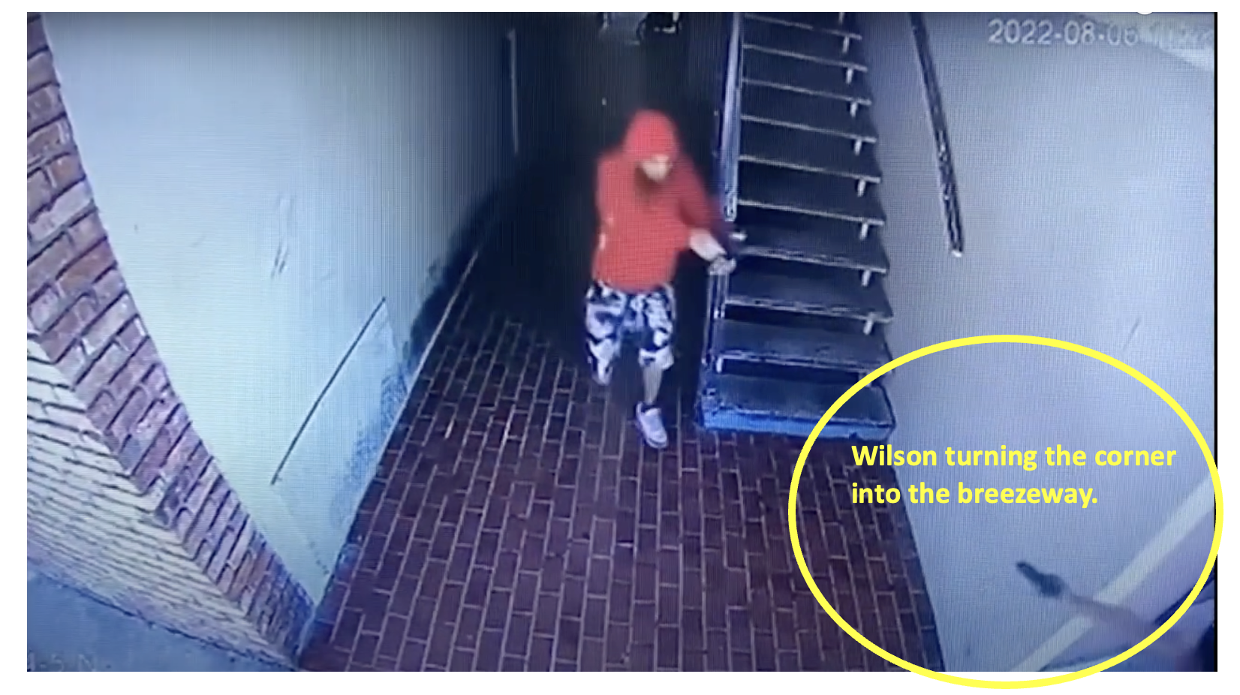

R. at 16 (0:10) (emphasis added).

In Wilson’s account of the story, Jay made a “sliding motion with his thumb across his neck,” to give Wilson the impression that Jay was going to kill him. R. at 60. Even if this could constitute a “menacing” act, Wilson is the *only* witness who reported that Jay did this. Gray, who was right next to Wilson, did not testify about this. The credibility of Wilson’s account of this is poor, and this Court should instead look to the only statement in that moment that *three out of four* witnesses testified to being said: “pop pop.” R. at 21, 34, 47.

The surveillance video captures that a bullet left Wilson’s gun first after Wilson followed Jay around the corner. R. at 16. By turning the corner into the breezeway and pursuing Jay with his gun out, Wilson became the aggressor.

### B. Jay’s acts of self-defense against Wilson were justified under § 776.041.

Individuals who are “attempting to commit” a “forcible felony,” or who “initially provoke” the use of force are excluded from using the SYG defense. § 776.041(1); § 776.041(2).

#### Jay was not an aggressor under § 776.041(1), as he was not committing a “forcible felony” before Wilson commenced his attack.

An aggressor is one who is “attempting to commit, committing, or escaping after the commission of, a forcible felony.” § 776.041(1). Forcible felonies include:

“treason; murder; manslaughter; sexual battery; carjacking; home-invasion robbery; robbery; burglary; arson; kidnapping; aggravated assault; aggravated battery; aggravated stalking; aircraft piracy; unlawful throwing, placing, or discharging of a destructive device or bomb; and any other felony which involves the use or threat of physical force or violence against any individual.”

Fla. Stat. § 776.08 (1995).

Jay was not attempting to commit a forcible felony and, thus, this exclusion does not apply to him. An alleged concealed carry violation is not a “forcible felony.” Fla. Stat. § 776.08. Furthermore, Jay’s charges for Attempted Murder in the Second Degree under § 782.04 and § 777.04 cannot serve as the basis for the § 776.041(1) exclusion to apply to his defense. “[T]rial courts should only give the [§ 776.041(1)] instruction when the State charges an independent forcible felony other than the one a defendant claims to have committed in self-defense.” *McCullough v. State*, 327 So. 3d 955, 958 (Fla. Dist. Ct. App. 2021). Jay’s charge for Attempted Murder in the Second Degree is the act that he committed in self-defense. Given that Jay has been charged with no *independent* forcible felony, the § 776.041(1) aggressor exclusion cannot be weaponized against his motion to dismiss.

#### Regardless of who was the initial aggressor, Jay was justified in defending himself against Wilson under § 776.041(2)(a).

An initial-aggressor cannot use the § 776.012 SYG defense. § 776.012; § 776.041(2). For the reasons stated above, Jay did not provoke this altercation. However, § 776.041(2)(a) adds that *even if* a defendant was the initial aggressor in a conflict, he is nonetheless entitled to stand his ground in self-defense against someone who is attacking him in response. § 776.041(2)(a). If the responding-aggressor’s “force or threat of force” against the alleged aggressor-defendant “is so great that the person reasonably believes that he or she is in imminent danger of death or great bodily harm” and “he or she has exhausted every reasonable means to escape such danger other than the use or threatened use of force which is likely to cause death or great bodily harm to the assailant,” then the defendant is entitled to stand his ground in self-defense. § 776.041(2)(a). This was the case for Jay.

##### Jay’s belief that Wilson posed a threat of death or bodily harm to him was reasonable.

An alleged aggressor-defendant’s belief in the responding-aggressor’s danger must be reasonable. § 776.041(2)(a). In a SYG pretrial motion to dismiss, the trial court judge must determine “whether, based on circumstances *as they appeared to the defendant when he or she acted*, a reasonable and prudent person situated in the same circumstances and knowing what the defendant knew would have used the same force as did the defendant.” *State v. Quevedo*, 357 So. 3d 1249, 1253 (Fla. Dist. Ct. App. 2023) (emphasis added). In a response to an immunity-based motion to dismiss in SYG cases, the State must “clearly and convincingly” prove that the defendant *“*at *no point”* had a “reasonable belief that deadly force was necessary to prevent imminent death or bodily harm” to himself. *Bouie*, 292 So. 3d at 481-82 (emphasis added) (granting immunity to a defendant after the State failed to “clearly and convincingly” prove that the defendant could not have reasonably thought, at any point, that the decedent’s “black object that looked like a gun” was not a gun).

Here, the State cannot “clearly and convincingly” prove that Jay “at no point” had a reasonable belief that Wilson posed a threat of death or great bodily harm to him. When Jay and Greg returned from breakfast, both brothers saw that it looked like Wilson was holding a gun. R. at 22, 33. Even Gray testified to this and that Wilson “looked angry.” R. at 46. Trying to avoid Wilson and his gun, Jay said “pop pop” only to give warning that he could defend himself if needed. R. at 21. Jay then heard one of Wilson’s friends laugh at him and say “he’s done.” R. at 22. This statement, Jay’s sight of a black object resembling a gun in Wilson’s pocket, and Jay’s knowledge of Wilson’s violent reputation (R. at 24) all lead to him developing the reasonable belief that Wilson now posed a threat to his life.

Surveillance footage supports this reasonable fear. The surveillance footage shows Wilson standing and staring at Jay, with his hand holding an object in his pocket. R. at 16. Although Wilson alleges that the object in his pocket was a cell phone (R. at 57), and that his friend Tony is the one who later handed him the gun (R. at 60), the video surveillance shows him holding the “phone” in the way that one would hold a gun:

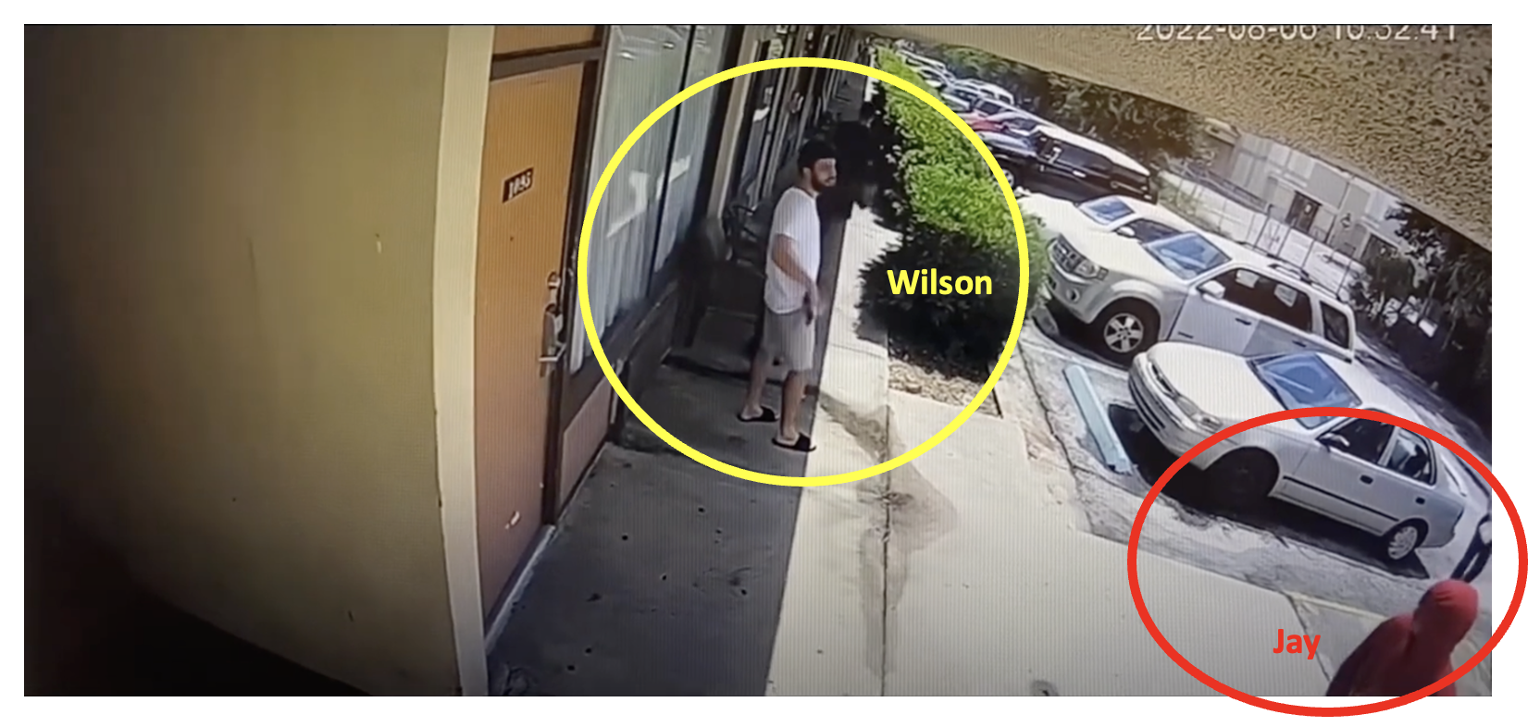

R. at 16 (0:07) (emphasis added). Significantly, the video does not show Tony handing Wilson anything at all. R. at 16.

Jay’s belief that Wilson posed a serious threat to his safety became even more reasonable when Wilson began to follow him into the breezeway. Wilson turned the corner into the breezeway with his gun already pointed. R. at 16. By that point, Jay’s gun was already pointed, too, because he heard someone yell, “Yo watch, he’s a dead man.” R. at 23. Greg also yelled that Jay needed to watch out after he turned the corner. R. at 34.

Jay had a reasonable belief that Wilson posed a serious danger to him. The State bears the high burden of “clearly and convincingly” proving that *at no point* would a reasonable person have felt that same danger. The State cannot meet that burden.

##### Wilson’s danger to Jay was imminent.

An alleged aggressor-defendant’s reasonable belief in the danger of death or bodily harm from a responding-aggressor must be “imminent.” § 776.041(2)(a). An imminent danger is one that is approaching so quickly that there is no time to call for help or “escape the compulsion without committing the crime.” *Pflaum v. State*, 879 So. 2d 93, 95 (Fla. Dist. Ct. App. 2004).

The danger that Wilson posed to Jay was imminent. Surveillance footage shows Wilson turning the corner into the breezeway where Jay was with his gun already drawn and pointed. R. at 16. With a gun pointed directly at his face, Jay faced an imminent risk of death and had no time to call for help.

##### Jay could not escape Wilson’s gunshots without using self-defense.

The alleged aggressor-defendant must have “exhausted every reasonable means to escape such danger” before he is entitled to stand his ground and use force against a responding-aggressor. § 776.041(2)(a). An individual has “exhausted every reasonable means to escape such danger” if there is no viable pathway for him to leave the scene of the altercation without exposing himself to the risk of death or great bodily harm. *Smith v. State*, 387 So. 3d 495, 497 (Fla. Dist. Ct. App. 2024) (finding that an individual who was pressed up behind a door and being punched had no reasonable means to escape and was justified in shooting the attacker).

Cornered in a breezeway with Wilson firing shots at him, Jay had no reasonable means to escape without defending himself, which justified his shot at Wilson’s shoulder. R. at 23. Wilson remained with a gun in his hands until he was shot in the back. R. at 23, 48. Jay’s shot at Wilson’s back is thus justified because Wilson still had a gun pointed at Jay while he was falling. *Id*. Although there is dispute about at what point Wilson began retreating, at this point, doubts must be resolved in favor of Jay until the State “clearly and convincingly” proves that Jay *did* have a reasonable means to escape without shooting.

Jay was not the aggressor in this conflict. Jay did not provoke Wilson to use deadly force and is entitled to use the § 776.032 immunity defense. Furthermore, the exclusions to its use in § 776.041 do not apply. Jay was not an aggressor committing a forcible felony under § 776.041(1). Jay did not provoke this conflict and, even if he had, § 776.041(2)(a) permitted him to use deadly force in self-defense. Jay is entitled to immunity as he was not an aggressor.

# Conclusion

For the foregoing reasons, Jay Cameron prays that this Court dismiss his charges for Attempted Murder in the Second Degree and Carrying a Concealed Weapon under Stetson statutes § 782.04, § 777.04, and § 790.01(2). Specifically, Jay Cameron asks for this Court to apply immunity through § 776.032.

DATED, this 1st day of September 2024.

Respectfully submitted,

/s/ Team # 118

Attorneys for the Defendant

1. Other jurisdictions have adopted similar statutes. *See*, Tex. Penal Code § 9.32 (2007); N.H. Rev. Stat. Ann. § 627:4 (2011); Wyo. Stat. Ann. §6-2-602 (2018); Ind. Code § 35-41-3-2 (2024).