Team No. 111

Case No. 2024-CR-319

IN THE
SUPERIOR COURT OF THE STATE OF STETSON
PINELLA COUNTY JUDICIAL DISTRICT

STATE OF STETSON

v.

JAY CAMERON,

Defendant.

DEFENDANT’S MEMORANDUM OF LAW IN SUPPORT OF
HIS MOTION TO DISMISS

/s/ 111
Attorneys for the Defendant
Table of Contents
INTRODUCTION 1

STATEMENT OF FACTS 1

ARGUMENT 3

I. Mr. Cameron is immune because he was not engaged in criminal activity when he defended himself from a violent drug dealer. 5

A. Mr. Cameron did not have a duty to retreat because he was not engaged in criminal activity at the time of the shooting. 6

B. Mr. Cameron’s use of force was justified because he reasonably feared for his safety and had no reasonable means by which to retreat. 11

II. Mr. Cameron is immune from prosecution under Stetson’s Stand Your Ground law because he was not the aggressor and was walking away from the man that ended up shooting him. 14

A. Mr. Cameron was not the aggressor as words alone cannot initially provoke Wilson’s attack. 15

B. Mr. Cameron was walking away from Wilson when he was forced to stand his ground. 18

CONCLUSION 20

TABLE OF AUTHORITIES
Cases

Bouie v. State,
292 So. 3d 471 (Fla. Dist. Ct. App. 2020) 4, 15

Brown v. United States,
256 U.S. 335 (1921) 3, 4, 14

Caudill v. Commonwealth,
27 Va. App. 81 (1998) 15

D.C. v. Heller,
554 U.S. 570 (2008) 4

Dorelus v. State,
747 So. 2d 368 (Fla. 1999) passim

Ensor v. State,
403 So. 2d 349 (Fla. 1981) passim

Gibson v. State,
576 So.2d 899 (Fla. 2d Dist. Ct. App. 1991) 7, 10

Jimenez v. State,
353 So. 3d 1286 (Fla. 2d Dist. App. 2023) 12, 20

McDonald v. State,
1988 OK CR 245, 764 P.2d 202 (Okla. Crim. App.) 15

Merritt v. OLMHP, LLC,
112 So. 3d 559 (Fla. 2d DCA 2013) 4

Mitchell v. State,
494 So. 2d 498 (Fla. 2d Dist. App. 1986) 6, 8

Rowe v. United States,
164 U.S. 546 (1896) 18

State v. Bogie,
125 Vt. 414 (1966) 15

State v. Corbett,
269 N.C. App. 509 (N.C. Ct. App. 2020) 16, 17

State v. Floyd,
186 So. 3d 1013 (Fla. 2016) 18, 19

State v. Hardy,
610 So.2d 38 (Fla. 5th Dist. Ct. App. 1992) 7, 10

State v. Johnson,
No. SC-2023-0251, 2023 Ala. LEXIS 144 (Dec. 15, 2023) 15

State v. Newsom,
563 N.W.2d 618 (Iowa 1997) 6, 8

State v. Quevedo,
357 So. 3d 1249 (Fla. Dist. Ct. App. 2023) 4, 16, 17, 18

State v. Spaulding,
298 N.C. 149 (1979) 16

Thompson v. State,
257 So. 3d 573 (Fla. Dist. Ct. App. 2018) 18

United States v. Alvarez,
755 F.2d 830 (11th Cir. 1985) 16

Statutes

Stetson Gen. Stat. § 776.041 14

Stetson Gen. Stat. § 776.012 passim

Stetson Gen. Stat. § 776.032 5

Stetson Gen. Stat. § 790.01(2) 6

INTRODUCTION
This Court should grant Jay Cameron’s Motion to Dismiss because he reasonably believed that his force was necessary to prevent death or great bodily harm, he did not conceal that he was armed to protect himself, and he was not the initial aggressor as he took no physical action towards Ryan Wilson to initiate conflict.
After Mr. Cameron indicated that he was armed to protect himself and walked away from Wilson, Wilson got a gun and approached Mr. Cameron from behind. Once only a few feet away from Mr. Cameron, Wilson began raising a gun. Mr. Cameron turned around and shot Wilson to protect himself. Because Mr. Cameron did not conceal the fact that he was armed or take any physical action towards Wilson to engage him, Mr. Cameron is justified in standing his ground. Thus, this case should be dismissed with prejudice.

STATEMENT OF FACTS
The idealist. Mr. Cameron is a young man seeking to “mind [his] own business and live [his] own life.” (Jay Cameron Test. 20:41-43.) Without a stable place to live, he often rents a room at the Boals Motel for its relative safety. (Jay Cameron Test. 19:34-35.) However, in the months preceding this incident, he routinely witnessed the violent intimidation perpetrated by Wilson. (Jay Cameron Test. at 20:45-52.)
The drug dealer. Well known in the area for his drug-dealing and violent past, Ryan Wilson is a convicted felon that hosts drug-fueled parties at the Boals Motel. (Wilson Test. 56:49-51, 57:83; Gray Test. 50:153-51:65; Ex. 7.) Admittedly territorial, Wilson “always know[s] who is coming and going” and doesn’t like those he perceives as “outsiders.” (Wilson Test. 56:54-55; Gray Test. 45:31.)
The incident. On the morning in question, Mr. Cameron was on his way to breakfast with his brother Greg when Wilson verbally accosted him, reminding him that the Boals Motel was his “turf” and calling Mr. Cameron a “dead man walking.” (Jay Cameron Test. 20:54-59; Greg Cameron Test. 29:38-30:41.) Despite the unsettling confrontation, the brothers continued to breakfast before returning to the motel. (Jay Cameron Test. 20:57-62; Wilson Test. 58:98.)
While walking back through the motel parking lot toward his room, Mr. Cameron once again confronted Wilson. (Jay Cameron Test. 20:61-21:65.) While he “didn’t want to deal” with Wilson, he made it clear to Wilson and his friend, Kenny Gray, that he was armed, and that Wilson should not “mess with” him. (Jay Cameron Test. 20:62-21:77; Gray Test. 46:62-47:78.) Mr. Cameron held a large .40 caliber handgun in his front sweatshirt pocket with his right hand, held his left hand in the shape of a gun, and exclaimed “pop-pop” to demonstrate to the those assembled in the parking lot that he was clearly armed. (Jay Cameron Test. 21:69-85; Gray Test. 46:62-47:78.) Mr. Cameron walked past Wilson and into the breezeway of the Boals Motel. (Greg Cameron Test. 34:156-35:160; Gray Test. 47:83-86, 48:97-100.) Wilson approached the corner of the building with a handgun in pursuit of Mr. Cameron. (Greg Cameron Test. 34:156-35:160; Gray Test. 47:83-86, 48:97-100.) Greg Cameron yelled to his brother in warning, telling him to “watch out.” (Jay Cameron Test. 22:109-23:110; Greg Cameron Test. 34:146-49.)
Wilson turned the corner and fired gunshots at Mr. Cameron from only a few feet away. (Jay Cameron Test. 23:112-24; Wilson Test. 60:146-51.) Mr. Cameron was shot in the stomach while Wilson suffered gunshot wounds to his upper chest and lower back. (Jay Cameron Test. 23:118-19; Officer Hernandez Supplemental Incident Rep. 17; Wilson Test. 60:153-61:163; Ex. 10.)
The charges. Mr. Cameron now stands charged with Attempted Murder in the Second Degree and Carrying a Concealed Weapon. (Long Form Information 67.) Mr. Cameron moves to dismiss the charges against him on the ground that he is immune from prosecution under Stetson’s Stand Your Ground statute.

ARGUMENT
Stetson’s Stand Your Ground law ensures an individual’s right to protect themselves without the obligation to retreat when faced with an imminent threat. This principle empowers law-abiding citizens to have the legal right to defend their most valuable asset: their own life. Brown v. United States, 256 U.S. 335 (1921). It has long been held that when a “man reasonably believes that he is in immediate danger of death or grievous bodily harm from his assailant he may stand his ground and that if he kills him he has not exceeded the bounds of lawful self-defense.” Id. at 343.
The Second Amendment embodies an individual right to self-defense subject to limitations. D.C. v. Heller, 554 U.S. 570, 622-27 (2008). Stetson embraces this right and justifies the use of deadly force when a person reasonably believes it is necessary to prevent death or serious injury, provided they are in a place where they have a right to be, they are not engaged in criminal activity, and they did not initially provoke the altercation. Stetson Gen. Stat. § 776.012. Mr. Cameron has established a prima facie case immunity under this statute. (See Arraignment Tr. 75.) Now, the State must prove by clear and convincing evidence that a defendant is not protected under this statute. Merritt v. OLMHP, LLC, 112 So. 3d 559, 561 (Fla. 2d DCA 2013). This means the “evidence must be of such weight that it produces in the mind of the trier of fact a firm belief or conviction, without hesitancy, as to the truth of the allegations sought to be established.” Bouie v. State, 292 So. 3d 471, 481 (Fla. Dist. Ct. App. 2020) (internal citations omitted).
The justice system does not permit the prosecution of individuals acting under this statute; thus, this case must be dismissed to protect future individuals attempting to save their own lives. State v. Quevedo, 357 So. 3d 1249 (Fla. Dist. Ct. App. 2023).

Mr. Cameron is immune because he was not engaged in criminal activity when he defended himself from a violent drug dealer.

Mr. Cameron was not engaged in a criminal activity when he defended himself against an armed and violent drug dealer. Thus, he is entitled to immunity from prosecution under Stetson’s Stand Your Ground law.
Pursuant to Stetson General Statute § 776.012, “a person is justified in using or threatening to use deadly force” if they reasonably believe such force is “necessary to prevent imminent death or great bodily harm to himself” and they do not have a duty to retreat when are not engaged in “criminal activity.” Stetson Gen. Stat. § 776.012. Furthermore, Stetson General Statute § 776.032 grants immunity from prosecution for the force permitted in Section 776.012. Stetson Gen. Stat. § 776.032. A defendant who is engaged in criminal activity may use force justifiably under a Stand Your Ground law if he has exhausted “all reasonable means within his own power, consistent with his own safety.” Garcia v. State, 286 So. 3d 348, 351 (Fla. 2d Dist. Ct. App. 2019)
Mr. Cameron is entitled to immunity under Sections 776.012 and 776.032 because he was not engaged in criminal activity when Gray observed him openly carrying a .40 caliber handgun across the Boals Motel parking lot. See Ensor v. State, 403 So. 2d 349, 354 (Fla. 1981); (Gray Test. 46:62-47:68.) Even if Mr. Cameron was carrying a concealed weapon, he was justified in using force because he exhausted all reasonable means consistent with his own safety after Wilson turned the corner with his gun drawn. See Garcia, 286 So. 3d at 351; (Jay Cameron Test. 22:106-23:116; Greg Cameron Test. 34:156-35:160.)

Mr. Cameron did not have a duty to retreat because he was not engaged in criminal activity at the time of the shooting.

Mr. Cameron did not illegally carry a concealed firearm without a license because he made gestures signaling he was armed with a gun and the gun was recognized by an eyewitness. A person illegally carries a concealed firearm when they do so “in a manner to conceal the existence of the firearm from the ordinary sight or knowledge of another person.” Stetson Gen. Stat. § 790.01(2) (emphasis added). “Ordinary sight” of a weapon refers to the “casual or ordinary observation” of another person witnessing the person carrying the weapon. See Ensor, 403 So. 2d at 354; State v. Newsom, 563 N.W.2d 618, 620 (Iowa 1997) (holding that a weapon is concealed if the observer must enter the vehicle and “peer over” the seat to see it); see also Mitchell v. State, 494 So. 2d 498, 500 (Fla. 2d Dist. Ct. App. 1986) (holding that the defendant’s handgun was not concealed because the officer recognized the butt of a carbine to be part of a firearm without moving); Cope v. State, 523 So. 2d 1270, 1271-72 (Fla. 5th Dist. Ct. App. 1988) (holding that the “critical question” turns on whether a person observing the person with the firearm knows the object in question to be a firearm); Ensor, 403 So. 2d at 355. When determining whether the observer knows the object to be a firearm, “common sense must prevail.” Ensor, 403 So. 2d at 354-55.
While intent to conceal the weapon is not an element of the crime, courts may consider testimony describing how the defendant used his body to conceal the weapon. See Dorelus v. State, 747 So. 2d 368, 371 (Fla. 1999) (internal citations omitted). Courts may consider the type and size of the weapon and how such physical characteristics impact a person’s ability to conceal it. See id.; see also Gibson v. State, 576 So.2d 899, 899 (Fla. 2d Dist. Ct. App. 1991); State v. Hardy, 610 So.2d 38, 40 (Fla. 5th Dist. Ct. App. 1992). Concluding that whether a weapon is concealed “should not depend” on the vantage point of one observer compared to another. Dorelus, 747 So. 2d at 372 (holding that a weapon in a car’s center console that was observable from the passenger side of the car and not readily observable from the driver side of the car was not a concealed weapon).
Mr. Cameron did not carry his large .40 caliber handgun in a manner designed to conceal its existence from the ordinary sight or knowledge of others. Just as the officer in Dorelus observed and recognized the “shiny silver butt of a gun sticking out” of a car console, Gray saw Mr. Cameron “holding a weapon – probably a gun” in the front pocket of his sweatshirt with his right hand and, according to his own testimony, knows “what it looks like when someone’s packing.” See Dorelus, 747 So. 2d at 373; (Gray Test. 47:67-68.) Unlike the observer in Newsom entering the car and peering over a seat, Gray did not need to move closer to Mr. Cameron nor manipulate his field of vision to see the weapon being carried by Mr. Cameron. See Newsom, 563 N.W.2d at 620; (Gray Test. 46:62-47:68.) As the firearms carried by the defendants in Mitchell and Cope were observed and recognizable as firearms, so too was the .40 caliber handgun carried by Mr. Cameron recognized by Gray to be a gun. See Mitchell, 494 So. 2d at 500; Cope, 523 So. 2d at 1271-72; (Gray Test. 46:62-47:68.) Mr. Cameron did not carry a concealed weapon prior to the shooting because Gray observed the weapon as Mr. Cameron walked through the parking lot past Gray and Wilson toward the breezeway of the motel.
Common sense dictates that Wilson and Gray knew Mr. Cameron was carrying a weapon when, as he walked past them, he made a hand gesture in the shape of a gun toward Wilson and said “pop-pop” during a tense confrontation between the hostile parties. Affirmatively answering the “critical question” set forth in Ensor, Gray knew Mr. Cameron was carrying a gun. See Ensor, 403 So. 2d at 355; (Gray Test. 46:63-47:78; Jay Cameron Test. 21:70-77; Greg Cameron Test. 29:38-30:47, 34:135-36.) Considering he saw the weapon in Mr. Cameron’s pocket, heard Mr. Cameron’s exclamation of “pop-pop” and other verbal threats, common sense dictates Gray knew Mr. Cameron was armed, particularly given Gray’s own experience living in the dangerous area. See Ensor, 403 So. 2d at 355; (Gray Test. 46:63-47:78; Jay Cameron Test. 21:70-77; Greg Cameron Test. 29:38-30:47, 34:135-36.) Common sense suggests that the totality of Mr. Cameron’s actions, explicit threats, and Gray’s personal experience would lead to him knowing Mr. Cameron was carrying a firearm.
This Court should consider how Mr. Cameron used his body to reveal his firearm by holding the large .40 caliber handgun in the front pocket of his hooded sweatshirt and using his left hand to make the shape of a gun as he walked by Wilson and Gray. Just as the defendant in Dorelus made no “attempt . . . to hide the presence of a firearm,” Mr. Cameron made no attempt to hide his firearm when he walked within several feet of Wilson and Gray, visibly holding his large handgun in his front sweatshirt pocket while making the shape of gun with his left hand. See Dorelus, 747 So. 2d at 371-73; (Jay Cameron Test. 21:67-86; Greg Cameron Test. 34:139; Gray Test. 46:63-47:78.) While intent to conceal a weapon is not necessarily an element of the crime charged, this Court should consider Mr. Cameron’s actions that showed he was armed with a firearm in his sweatshirt pocket.
The size and nature of the .40 caliber handgun Mr. Cameron was carrying indicates it was difficult to conceal and was more easily observable by Wilson and Gray. As the large knives carried by the defendants in Gibson and Hardy were “by their very nature, more easily observable,” so too was the large .40 caliber handgun carried by Mr. Cameron. See Dorelus, 747 So. 2d at 371; see also Gibson, 576 So.2d at 899; Hardy, 610 So.2d at 40; (Ex. 5; Jay Cameron Test. 21:70-71; Gray Test. 46:63-47:78.) The size of Mr. Cameron’s firearm made it more readily observable, suggesting it was not concealed as he walked through the parking lot past Wilson and Gray.
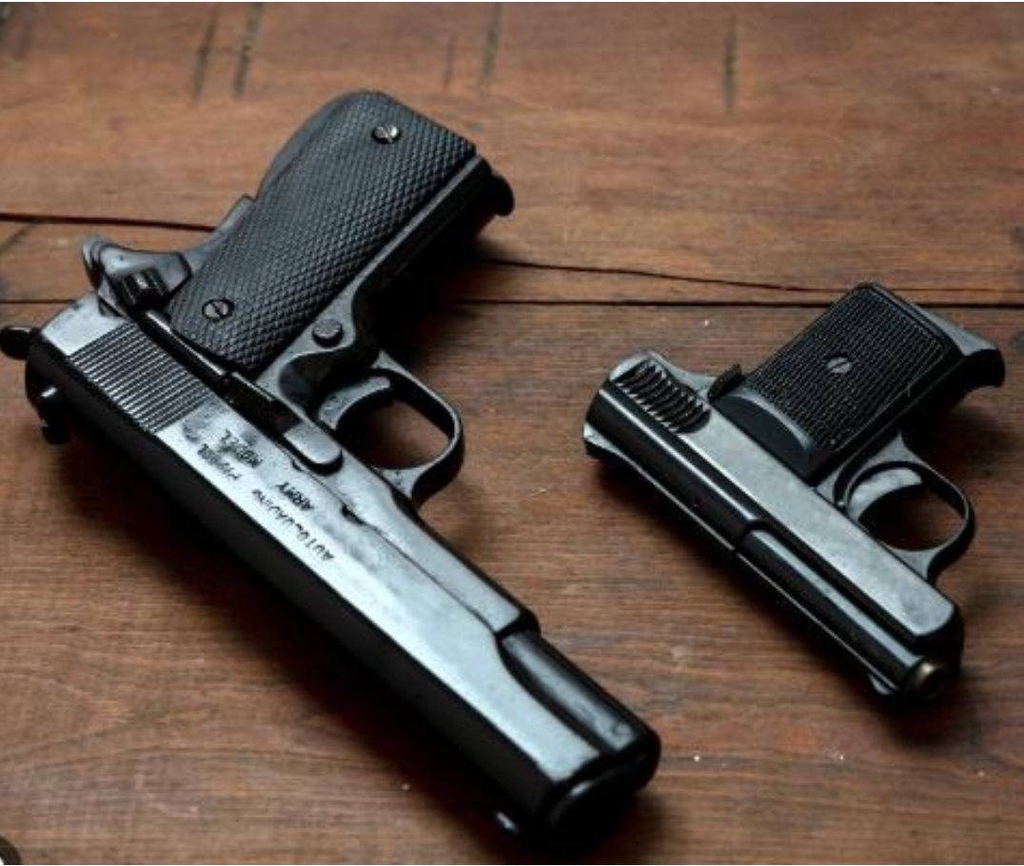
Admitted Exhibit 5 – Photograph of two semi-automatic handguns found in Room 1077.

Although Wilson reportedly did not immediately recognize the handgun in Mr. Cameron’s sweatshirt pocket, Mr. Cameron did not carry a concealed weapon because Gray recognized the handgun from a different vantage point. Just as the defendant’s weapon in Dorelus not considered concealed because it could be seen by an observer looking through the passenger window, Mr. Cameron’s handgun was seen by the ordinary observer because Gray was able to identify it from where he was standing. See Dorelus, 747 So. 2d at 372; (Gray Test. 46:63-47:78; Wilson Test. 58:108-59:117.) Because Gray recognized that Mr. Cameron was carrying a handgun from his vantage point, the .40 caliber gun was not concealed.
Mr. Cameron did not conceal his large .40 caliber handgun when he carried it across the Boals Motel parking lot in front of Wilson and Gray because he did so in a manner that made the gun visible to Gray. He did so by holding the large gun in his front sweatshirt pocket, demonstrably gesturing to the observers with his hand in the shape of a gun, and saying “pop-pop” as a warning.

Mr. Cameron’s use of force was justified because he reasonably feared for his safety and had no reasonable means by which to retreat.

Mr. Cameron did not have a duty to retreat when he quickly turned around following a warning from his brother, immediately confronted an armed and violent drug dealer, and shot at his would-be assailant in reasonable fear for his own safety because he had no reasonable means of escape.
If a person “reasonably believes” that the use or threat of deadly force is necessary to prevent imminent death or great bodily harm to himself, the use of such force is justified to “prevent the commission of a forcible felony.” Stetson Gen. Stat. § 776.012. “Reasonable” belief is measured not by the personal belief of a party, but rather a “reasonably prudent person's state of mind.” Durham, 2024 WL 1478816, at *4 (internal citations omitted) (holding that the defendant’s personal belief that he needed to “reengage” with assailants to protect his friends after retreating to relative safety was not sufficient to justify the use of deadly force). A defendant who is engaged in a criminal activity may use force justifiably under a Stand Your Ground law if he has exhausted “all reasonable means within his own power, consistent with his own safety.” Garcia, 286 So. 3d at 351 (emphasis added); see also Jimenez v. State, 353 So. 3d 1286, 1288 (Fla. 2d Dist. App. 2023). Evidence of a party’s previous acts of violence may be admitted to demonstrate the reasonable fear experienced by the defendant acting in self-defence. See United States v. James, 169 F.3d 1210, 1214 (9th Cir. 1999) (holding that recollections of abusive boyfriend’s previous violent acts by manslaughter defendant were sufficient to establish a defendant’s reasonable fear for her daughter’s life).
When a deadly encounter begins and ends in a matter of seconds, a person’s ability to escape may disappear. Jimenez, 353 So. 3d 1286-88 (holding that, despite being engaged in criminal activity, the defendant established a prima facie case of self defense when the brief nature of the episode precluded any available retreat before resorting to deadly force).
Considering the imminent threat of Wilson mere feet away with a weapon, the death threats previously uttered by Wilson, his knowledge of Wilson’s violent past, and how quickly the encounter happened, Mr. Cameron reasonably feared for his life, and he had no ability to escape. Therefore, Mr. Cameron had no duty to retreat.
Mr. Cameron reasonably feared for his own safety based on the imminent danger posed by Wilson following him with a gun. Mr. Cameron had just walked by a clearly armed and reputedly violent, territorial drug dealer before being warned desperately by his brother that he should “watch out.” See James, 169 F.3d at 1214; (Jay Cameron Test. 22:94-23:111; Greg Cameron Test. 34:143-52.) Mr. Cameron was aware that Wilson was armed, had been threatened by Wilson, and was aware of Wilson’s “violent reputation.” See James, 169 F.3d at 1214; (Jay Cameron Test. 20:54-59, 22:96-23:111.) Given the circumstances present, a “reasonably prudent person” would fear for their life if they turned around and confronted an armed drug dealer. See Durham, No. 23-10779, 2024 WL 1478816, at *4; (Jay Cameron Test. 20:54-59, 22:96-23:111.) Mr. Cameron reasonably feared for his own safety when he turned around and shot at an armed and violent drug dealer that was following him.
Mr. Cameron had no ability to escape because his encounter with Wilson began and ended in a matter of seconds. Just as the episode in Jimenez “began and ended within a matter of seconds” and forced the defendant to resort to deadly force in defense of his life before retreating, the shooting between Wilson and Mr. Cameron lasted less than two seconds and thus precluded Mr. Cameron from attempting any possible means of escape. See Jimenez, 353 So. 3d 1286-88; (Jay Cameron Test. 23:114-15; Ex. 8, at 00:08-00:10.)
As Mr. Cameron had no reasonable means by which to retreat without remaining in imminent physical danger, his use of force against an armed, violent drug dealer was justifiable.

Mr. Cameron is immune from prosecution under Stetson’s Stand Your Ground law because he was not the aggressor and was walking away from the man that ended up shooting him.

When the fear of death is imminent, a person has the right to “stand [their] ground.” Brown v. United States, 256 U.S. 335, 343 (1921). Stetson’s General Statutes protect this right by justifying the use of deadly force if a person reasonably believed that such force was necessary to prevent death or great bodily harm, and if the person using force was not engaged in criminal activity at the time and in a location where they had a right to be. Stetson Gen. Stat. §776.012. A person may not be immune from prosecution under this statute if they initially provoked the danger or acted unlawfully and then failed to withdraw from the threatened use of force. Stetson Gen. Stat. §§ 776.012, 776.041. It is unnecessary to address whether Mr. Cameron was in the location lawfully. (See Arraignment Tr. 73-74.) Mr. Cameron did not initially provoke the danger, yet he still tried to retreat. (Jay Cameron Test. 20:62-2165, 22:107-23:111; Greg Cameron Test. 34:152-58; Gray Test. 47:80-86; Wilson Test. 60:141-44.) The State will be unable to prove by “clear and convincing evidence” otherwise. Bouie v. State, 292 So. 3d 471, 480 (Fla. Dist. Ct. App. 2020) (holding that “clear and convincing evidence is evidence making the truth of the facts asserted highly probable”) (internal citations omitted).

Mr. Cameron was not the aggressor as words alone cannot initially provoke Wilson’s attack.

Words can hurt, but they do not qualify a person as an aggressor under Stetson’s Stand Your Ground law. Numerous courts have held that mere words or verbal assaults do not justify the use of deadly force. An “initial aggressor refers to someone who engaged in a forceful action or procedure, as in an unprovoked attack, against another; it does not encompass someone who simply created a controversy or verbally confronted someone else.” State v. Johnson, No. SC-2023-0251, 2023 Ala. LEXIS 144, *12 (Dec. 15, 2023) (internal citations omitted). A person does not lose their right to stand their ground by “merely starting an argument.” Id. When identifying the aggressor, “[m]ere words, without more, do not constitute provocation or aggression.” United States v. Alvarez, 755 F.2d 830, 846 (11th Cir. 1985).
Aggressors fight physically. A person who “aggressively and willingly enters into the fight without legal excuse or provocation is properly deemed the aggressor.” State v. Corbett, 269 N.C. App. 509, 566 (N.C. Ct. App. 2020) (internal citations omitted). Courts have considered the following factors when identifying the aggressor: “circumstances that precipitated the altercation; the presence or use of weapons; the degree and proportionality of the parties' use of defensive force; the nature and severity of the parties' injuries; or whether there is evidence that one party attempted to abandon the fight.” Id. These factors require that the altercation be physical rather than verbal. However, a defendant simply being armed “is not evidence that he was the aggressor if he made no unlawful use of his weapon.” Id. at 569. A defendant who arms themselves for protection and uses force when approached by a threatening person with a hand in their pocket is not an aggressor. State v. Spaulding, 298 N.C. 149, 155 (1979).
In State v. Quevedo, a verbal argument escalated to physical action which defined the aggressor. Quevedo, 357 So. 3d at 1249. The defendant and his neighbor were having a verbal argument. Id. at 1251. The defendant was insulting the neighbor and the neighbor then threatened to “bust out [the defendant’s] teeth.” Id. at 1250. The defendant had a bleeding disorder, so any physical harm could be fatal. Id. The defendant then indicated he had a gun, but the neighbor waved his arms and still advanced towards the defendant. Id. at 1251. The defendant justifiably shot the neighbor, as the defendant was not the initial aggressor, he had the right to be in the place he was, and he “reasonably believed the use of deadly force was necessary to prevent imminent death or great bodily harm.” Id. at 1252. The court held that the neighbor was the aggressor as he approached the defendant in a way that caused the defendant to fear for his life. Id.
Mr. Cameron used his words, not his weapon, until he was forced to in reasonable fear for his life. (Jay Cameron Test. 21:75; Greg Cameron Test. 34:136; Gray Test. 45:39, 47:70; Wilson Test. 57:70-76.) Mr. Cameron and Wilson did exchange unkind words; they allegedly made comments to each other about whose “turf” they were on, someone getting hurt, someone being “done,” and making the sound “pop pop.” (Jay Cameron Test. 20:54-57, 21:75, 22:102, 23:110; Greg Cameron Test. 29:38, 32:92-93, 34:143-44; Gray Test. 45:38-46:42, 47:70; Wilson Test. 57:70-76.) Mere words do not automatically make someone an aggressor under Stand Your Ground law. Being an aggressor requires physical action and consideration of the above factors. Corbett, 269 N.C. App. 509 at 566. Mr. Cameron verbally indicated he had a gun. (Jay Cameron Test. 21:75; Greg Cameron Test. 34:136; Gray Test. 45:39, 47:70; Wilson Test. 57:70-76.) As Mr. Cameron walked away from Wilson, Wilson retrieved a gun, and approached Mr. Cameron. (Greg Cameron Test. 34:143-54; Gray Test. 47:83-86; Wilson Test. 60:141-52.) Mr. Cameron feared for his life when he turned around to see Wilson, just feet away, and visibly holding a gun. (Jay Cameron Test. 22:106-23:111, 25:160-62; Greg Cameron Test. 34:143-54.) As the would-be assailant was the aggressor in Quevedo, Wilson was the aggressor when he approached Mr. Cameron forcing him to fear for his life. Quevedo, 357 So. 3d at 1252; (Jay Cameron Test. 22:106-23:111, 25:160-62; Greg Cameron Test. 34:143-54; Gray Test. 47:83-86.) As any reasonable person would to prevent imminent death, Mr. Cameron shot at Wilson.

Mr. Cameron was walking away from Wilson when he was forced to stand his ground.

Even if a person is initially deemed the aggressor, they may reclaim their right to stand their ground when they walk away from the confrontation. Self-defense laws claim that “the law will always leave the original aggressor an opportunity to repent before he takes the life of his adversary.” Rowe v. United States, 164 U.S. 546, 556 (1896). One altercation can be viewed as two separate events with different initial aggressors respectively; the original aggressor can reclaim the right to stand their ground. Thompson v. State, 257 So. 3d 573, 581 (Fla. Dist. Ct. App. 2018).
In State v. Floyd, there was a physical fight between Floyd and Banton. State v. Floyd, 186 So. 3d 1013 (Fla. 2016). Banton indicated that he had a gun and walked away from Floyd. Id. at 1015. Floyd then went to retrieve a gun and reapproached Banton. Id. It was in dispute who shot first. Id. However, Floyd was convicted and deemed the initial aggressor in the second event because he went to retrieve the gun and then approached Banton. Id. Additionally, even if Floyd was the initial aggressor in the first event, he had a duty to withdraw and stay away from Banton. Id.
Here, Mr. Cameron was not the aggressor. Nonetheless, he still attempted to retreat and get away from Wilson when, after exchanging words, Mr. Cameron continued to walk past Wilson into the breezeway. (Jay Cameron Test. 22:106-23:111, 25:160-62; Greg Cameron Test. 34:143-54; Wilson Test. 60:141-52.)
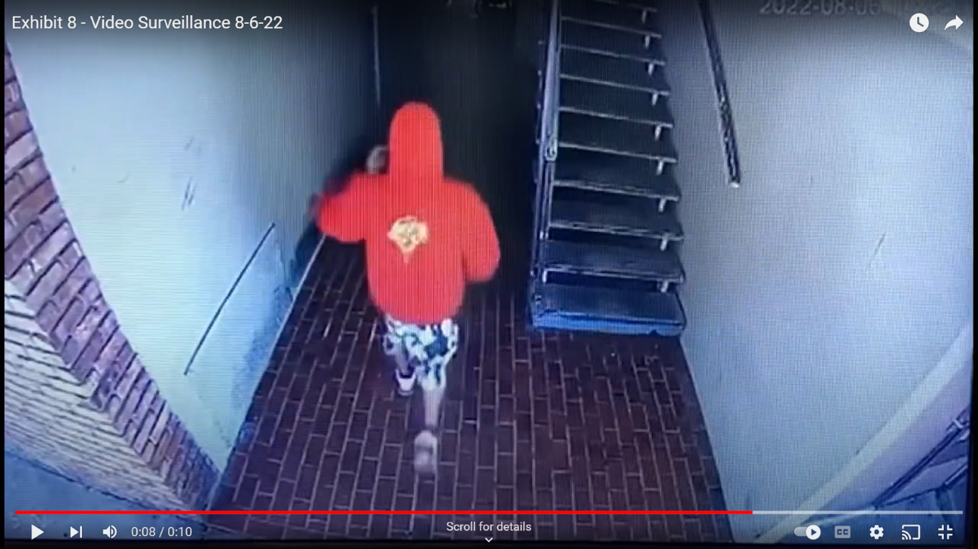
Admitted Exhibit 8 - Video Surveillance 8-6-22 0:08/0:10
Were Mr. Cameron’s words to qualify him as the initial aggressor, a second event occurred in the altercation when Wilson retrieved a gun and approached Mr. Cameron, who was headed down the breezeway away from Wilson. (Wilson Test. 60:141-52.) Even if Mr. Cameron had a duty to retreat, he was already walking away and with no ability to retreat when he heard a loud warning him to turn around only to then see Wilson just feet away with a firearm aimed at him. (Jay Cameron Test. 22:106-23:111, 25:160-62; Greg Cameron Test. 34:143-54; Gray Test. 47:83-86.)
Mr. Cameron is immune from prosecution because he was not the initial aggressor and was walking away from Wilson when warned to turn around and defend himself against a violent drug dealer.

CONCLUSION
For the foregoing reasons, Mr. Cameron respectfully requests that this Court grant his Motion to Dismiss. Mr. Cameron reasonably believed that his force was necessary to prevent death or great bodily harm, he did not conceal the fact that he was armed to protect himself, and he was not the initial aggressor as he took no physical action toward Wilson.

Respectfully submitted,

/s/ Team xxx
Attorneys for the Defendant

See, e.g., McDonald v. State, 1988 OK CR 245, ¶ 12, 764 P.2d 202, 205 (Okla. Crim. App.) (“[W]ords alone do not transform the speaker into an aggressor.”); State v. Bogie, 125 Vt. 414, 417, 217 A.2d 51, 55 (1966) (“[P]rovocation by mere words will not justify a physical attack.”); Caudill v. Commonwealth, 27 Va. App. 81, 85, 497 S.E.2d 513 (1998) (“[W]ords alone, however insulting or contemptuous, are never a sufficient provocation for one to seriously injure or kill another.”).

