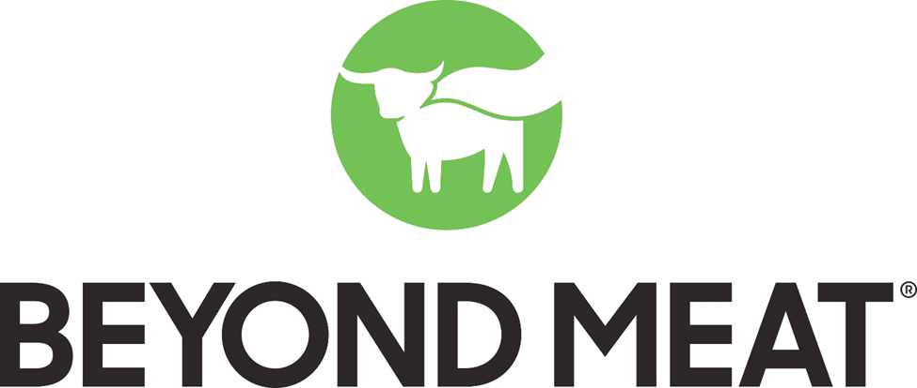

THE FUTURE OF PROTEIN

Stetson University
Roland George Investments Program

Stock Pitch – Sample Report

Beyond Meat

Stetson University
This report is published for educational purposes
only for the Roland George Investments program

Ticker: BYND
Consumer Staples Sector: Alternative Meat
Current Price: $77.3 as of 11/24/19
Date: 11/25/2019
Recommendation: BUY

MARKET SNAPSHOT
Ticker | BYND
Shares Outstanding | 61.5 M
Market Cap | 4.76 B
Beta | 0.78
Adj. 52 Week High | $239.71
Adj. 52 Week Low | $45.00
Source: Bloomberg
Business Description

Headquarters | El Segundo, CA
Founded | 2009
IPO | 2019
Employees | 257
Beyond Meat, Inc. manufactures, markets, and sells plant-based meat products in the United States and internationally. The company sells its products under the Beyond Beef, Beyond Chicken, The Beyond Burger, Beyond Meat, Beyond Sausage, Eat What You Love, and The Cookout Classic brand names. Their products can now be found at over about 58,000 grocery stores, restaurants, hotels, universities and beyond.
Table 1: Company Information
Source: Bloomberg
With increasing awareness of the ill-effects of consumption of animal-based meat, consumers are looking for healthier options and this is where this company comes in: Beyond Meat offers meat produced directly from plants, an innovation that enables the consumers to experience the taste, texture, and other sensory attributes of popular animal-based meat products, while enjoying the nutritional benefits, and guiltless joy of eating plant-based meat products.
The company was founded in 2009 by current CEO Ethan Brown with the mission to provide a better, and more sustatinable way to feed the planet, by developing delicious plant-based burgers, beef, sausage, crumbles and other meat alternatives. By doing so, the company believes it is addressing the following growing global issues: human health, climate change, scarcity of natural resources, and animal welfare.
The company has 2 main operating segments:
1- Retail Chain (55% of Revenue) includes the sales of its flagship plant-based meat products in meat cases through their retail partners which include names like Walmart, Publix, Whole Foods Market, and others (Figure x). The retail chain revenue has surged over the past 3 years driven by the flagship product – The Beyond Burger.
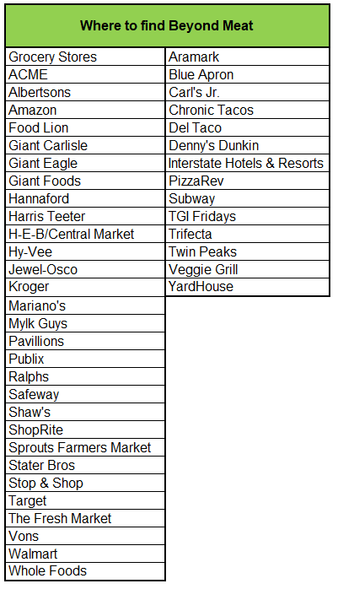
2- Restaurant & Foodservice outlets (45% of Revenue) includes the sales of the Beyond Burger and Beyond Sausages through ~ 12,000 restaurant and foodservice outlets (Figure x). Growth is driven by increasing sales of The Beyond Burger and Beyond Sausage. The company sees future growth as a result of ti-ups with giants Dunkin’ Donuts, and others.
Table 2: Where to find Beyond Meat

Competitive Positioning

Why is Beyond Meat Different?

In terms of Product, Beyond Meat uses pea protein instead of soy protein. Other ingredients include water, refined coconut oil, rice protein, expeller-pressed canola oil, and the red color comes from beet extract, rather than heme from leghemoglobin, like in the other meat-alternative products (Impossible Patty).

In terms of their market position, industry experts believe that BYND can defend its leading position in refrigerated plant-based alternative meat sales as long as the focus remains on innovation, product-line extensions and ensuring sufficient production capacity.

Research conducted by the Center for Sustainable systems at the University of Michigan, the researchers found that compared to the typical beef burger, Beyond Meat’s burger uses significantly less water, land, energy, and generates fewer Greenhouse Gas Emission (GHGE).

Bottom line, Beyond Meat’s products are currently leading the plant-based meat market because (a) they are healthier, (b) the company is essentially focused on constant innovation and improvement, and (c) it is ethically and environmentally a better choice.

Market Overview

The company faces fierce competition in the $947.5 billion (2018) global meat industry, from conventional animal-protein companies such as Cargill, Hormel, JBS, Tyson, WH group, as well as the plant-based protein brands including Boca Foods, Field Roast Grain Meat Co., Gardein, Impossible Foods, Lightlife, Morningstar Farms, and Tofurky. Competition is based on, product quality and taste, brand recognition and loyalty, product variety, product packaging and design, shelf space, reputation, price, advertising, promotion, and nutritional claims.

Additionally, Nestle launched a meatless burger in Europe this past April under its Garden Gourmet brand, partnering with McDonald's in Germany, and will introduce it in the U.S. under its Sweet Earth banner later this year. In Q3 2019 Tyson Foods (NYSE: TSN), which had been an investor in Beyond Meat until its IPO, announced it will be launching a plant-based meat substitute this summer.

The company can grind out a bigger niche as it has a differentiated product that can help it to stand out and to thrive in an increasingly crowded field of competitors, some of which mentioned above have larger scale and capabilities.

Recent Performance

Figure 1: BYND equity vs. IWV Russell 3,000 Growth ETF
BYND

- May 5th, 2019

BYND soared in terms of market value and becomes U.S.’s Top IPO for the year. Beyond Meat Inc. Piled on the market value as it rose as high as 192 percent from its IPO price of $25 a share.

- June 11th, 2019

At point B, BYND stock fell in its worst day since its IPO. JP Morgan’s Ken Goldman cut his recommendation on the stock to neutral from overweight, saying it is now too expensive, with a $10 billion enterprise value that’s 27 times estimated 2020 sales. Although a downgrade, JP Morgan analysts reiterate it as a purely valuation call.

- July 30th, 2019

The shares of BYND nosedive on the news of a plan by inside shareholders and the faux-meat company to sell more than 3 million shares, just three months after their IPO. This transaction would mean early investors such as Kleiner Perkins and Obvious Ventures and executives including CEO Ethan Brown take profits on a small portion of their stakes after an almost 800% gain. This is essentially meant to help Beyond fund increased production and marketing as the company faces fierce competition in the crowded vegan marketplace. The news caused the stock to slide sharply before putting a lid on losses over another upbeat earnings report from Beyond Meat, with sales surpassing analysts’ estimates.

- August 1st, 2019

The shares of Beyond Meat Inc. tumbled after inside shareholders priced a secondary offering at $160 per share handing early investors a slice of the profits. The offering price represents an 18.58% discount to last day’s closing price, unusually steep for an offering of this size. Furthermore, the company also boosted their sales guidance as it attracts a growing list of restaurant clients for its plant-based burgers and sausages.

Growth Drivers

Market Opportunity & Beyond Meat’s Position

The plant-based alternative-meat market may grow to $2.8 billion by 2023, based on Euromonitor data. Beyond Meat’s strong market share and plans to spend heavily on further R&D position the company well to capitalize on an alternative-meat market that may surge to $10 billion over the next decade if sales growth and market penetration mimic that of plant-based milks. This would still represent only 7% of the $1.4 trillion global meat industry.

Plant-based meat accounts for just under 1% of total meat category sales, while plant-based milks have grown to 13% of total milk category sales, jump-started in 1999 when Silk put soy milk in the dairy case, making it a more easily discoverable alternative for shoppers. Improved taste, broader and availability of plant-based alternatives in grocers' refrigerated meat sections should help propel a similar surge in consumer adoption and sales growth. Additionally, consumers are increasingly focused on the health and environmental attributes of the foods they purchase. Hence, a part of this is the intent to reduce meat consumption which Beyond Meat is ready to capitalize on. The taste, quality, cost and accessibility of the products in the industry will ultimately help continue the surge in sales growth.

The plant-based food industry has higher growth rates than conventional foods, albeit off a much smaller sales base. U.S. retail sales of plant-based foods reached $3.7 billion in 2018, up 17% vs. the prior year, based on Nielsen and SPINS data. Venture capital and private equity investments in companies in this market are poised to accelerate, as is M&A, as companies seek scale and efficiencies to compete effectively.

Strong Sales Growth Offsets Heavy Investments

Beyond Meat has operated at a loss since its inception, as the focus has been on investing in research and development to create and improve its products, adding manufacturing capabilities and advertising. In the meanwhile, rapid sales growth is helping to offset these costs, nudging the company towards profitability. Revenue has soared to $67.3 million, in the most recent quarter, from $6.2 million in 1Q17. While the company will likely remain unprofitable on a net basis until 2020, Beyond Meat has said it expects to achieve a profit this year after taking out taxes, interest and one-time expenses.
Figure 4: Gross Margin (%) and R&D/Net Sales (%)
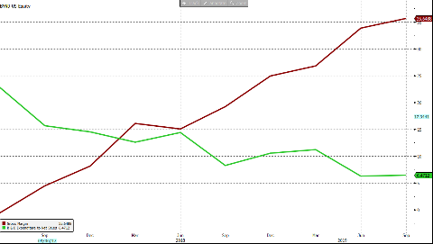
Gross Margin Improves as Scale Increases
GROSS MARGIN

Beyond Meat's gross margin should continue to expand over the next few years. The company will deliver gross profit improvement via better volume leverage and scale-related cost savings. An increase in the amount of product sold is helping to generate operating leverage and production efficiency improvements. A shift in product mix toward more refrigerated items is also aiding gross margin. As the company gains scale, cost savings associated with procurement of raw materials and packaging components as well as improved supply chain and distribution efficiencies should be realized, aiding margin.
Source: Bloomberg
R&D EXPENSE / NET SALES

Operational Excellence
BYND has increased their distribution points by more than 75% to 58,000 since the IPO and have beaten Wall Street consensus estimates. In the last quarter, BYND grew YoY revenues by 247% to $92 Million and had two quarters of positive EBITDA. The EBITDA margin for 3Q19 was 8.5%. While BYND maintained debt at $30.9 Million, they have increased their cash position to $312 Million thanks to the proceeds of the offering ($37.7 Million). In 2Q19, free cash flow was only a burn of $2 Million and had a cash position of $ 280 Million. So, the capital raised the following month was not needed.

Reasons to Buy

First-Mover Advantage
BYND has a first-mover advantage as it was the first supplier of plant-based foods to IPO early this year. Clearly a mainstream market for plant-based protein has been growing exponentially. Consumers are driven to meat substitutes by environmental and sustainability factors, as well as the ongoing trend toward healthy eating. Beyond Meat has been able to develop a burger option that is widely considered delicious and there is a perception among consumers that they are limiting their environmental footprint. As of today, BYND is facing a direct competition solely from Impossible Foods. BYND has the chance to tap in these shortages of supply and increase their market share over their direct competitors. The company recently closed a deal with Dunkin.
Pure Play
BYND focuses entirely on the creation of plant-based protein products. By investing all the capital at their disposal for the production on this specific type of food have been able to continuously lower their costs of production and their operating expenses as a percentage of sales. By being a pure play, the stock also provides a good opportunity for investors to buy in a company that is specifically targeting these plant-based products growing demand.
Possible Take-over target
As mentioned above, BYND was one of the first movers within the plant-based protein industry. This allowed the company to get a competitive market share and positioning within this segment of the market. As other large well-capitalized food players such as Tyson and Nestle are also looking to develop similar products in this space, with a medium-low market cap of $5B, we see BYND being a possible takeover target.
Investment Risks

The Health Argument

Although it seems like a plant-based burger should have a "cleaner" ingredients label, it's actually more complicated. An animal meat burger has one ingredient: beef. A Beyond Meat burger, on the other hand, has 18 ingredients. Carl's Jr. bills its Beyond Famous Star Burger -- featuring a meatless Beyond Burger -- as a "healthier option," but once you add a bun, cheese, lettuce, tomato, mayo, pickles, onions, and special sauce, you're looking at a sandwich with 710 calories, 40 grams of fat (no saturated or trans-fat, though), 1,550 milligrams of sodium, and 12 grams of sugars. A McDonald's Big Mac nutrition label is slimmer than that with 540 calories, 28 grams of fat (10 grams saturated and 1-gram trans), 940 milligrams of sodium, and 9 grams of sugars. On the carb front, the Carl's Jr. burger has 61 grams while the Big Mac has 46. In a cholesterol matchup, the Carl's Jr. sandwich has 30 milligrams while the McDonald's sandwich has 80.

More Expensive than Beef

Beef is expensive, no question, but two Beyond Meat quarter-pound patties at Target sell for $6, or the equivalent of $12 per pound. A one-pound package of 93% lean ground beef at Target goes for $5, or less than half the price.
You will also pay $2 more for the Beyond Meat option at Carl's Jr. than you would for the same beef burger, which might cause meat fans to question why you would pay up for near-meat when you could have the real thing for less.

Beyond the Burger

One risk that Beyond Meat is mitigating is that until recently it didn't make a "significant portion" of its burgers, but rather farmed out the process to two third-party manufacturers, CLW Foods and FLP Foods. Ironically enough, they are two big ground-beef producers. However, Beyond Meat recently expanded the number of co-manufacturers from two to five, and it is building out its own capabilities, opening a new facility in Europe, mitigating the risk of a processor shutting it out.

Financial Analysis
Figure 5: Revenue & Revenue Growth

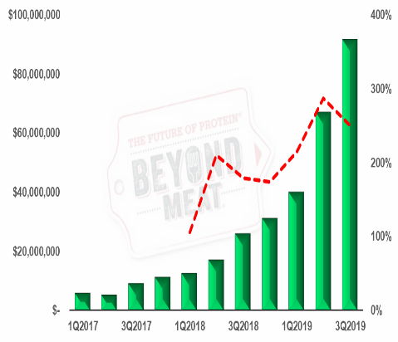
Revenue Growth

From 2019 to 2020 BYND is expecting strong revenue growth year-over-year ranging from 70% to 215%. We expect a strong double-digit revenue growth to continue through the end of 2026. Figure 5 illustrates the rapid revenue growth of BYND.

Earnings Growth

The company is expected to turn profitable for the first time sometime during the second half of 2020. Moving forward the company is expected to increase its gross margin and decrease its operating expense as a percentage of sale, we expected a double-digit earnings growth starting from 2022.
Source: Bloomberg
ESG
Corporate Governance
BYND practices satisfactory corporate governance across management, directorship, and shareholder interests. The current suite of executives has held a variety of roles in different companies and within BYND pertaining to their current position, allowing for an experienced and competent top-level management team. The Board of Directors is comprised of a majority of independent, experienced and competent personnel. Executives and Directors are compensated with both stock and salary, increasing the personal stake in the company more than with only-salaried compensation.
Environmental and Social Responsibility
BYND’s positioning as a socially and environmentally responsible company provides inherent sustainability. Producing vegan substitutes for meat helps address climate change, resource conservation, and animal welfare, creating a substantial positive impact on the environment. Providing a product for individuals with dietary restrictions or whom are concerned with supporting the environment also creates a net positive social impact in that the company gives acceptable solutions to those who may want to abstain from meat. As the Earth’s environmental condition continues to decline, BYND stock will be a safe-haven in the decline of environmentally-harmful or socially irresponsible companies.

Recommendation
Therefore, because of Beyond Meat’s high revenue growth which is attributed to their market position and the growth of plant-based meat market as a whole we recommend the Roland George Investments Program to invest in BYND.
Sources:

Bloomberg
Thomson Reuters
Morning Star
Yahoo Finance
Seeking Alpha
Statista
Federal Reserve
Beyond Meat 10K
Beyond Meat 10Q
Beyond Meat Investment Presentation

Disclosures:

This report is strictly for educational purposes produced for the Roland George Investments Program

