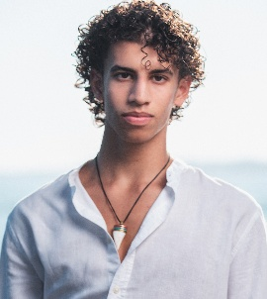
Psychology Department Sure Grant Recipients
- Leonardo Giorgioni, 2025 SURE Grant Recipient, "The Influence of Educational Video Interventions on Hurricane Risk Perception: The Role of Affective Response and Graphical Literacy" - Maris Award
Mentor: Michael Eskenazi
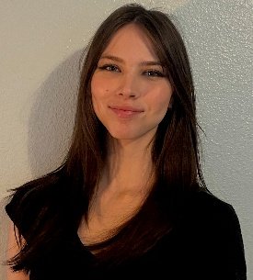
- Elena Edwards, 2025 SURE Grant Recipient, "The Effects of tDCS on Pitch Perception in Music and Non-Music Students"
Mentor: Sarah Garcia-Beaumier
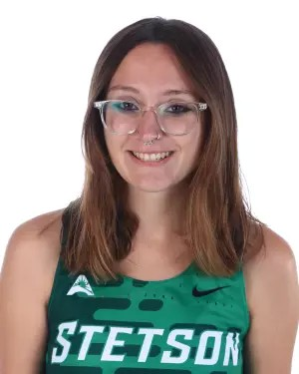
- Blair Durda, 2024 SURE Grant Recipient, "Kirtan Kriya Meditation on Amnestic and Non-Amnestic Mild Cognitive Impairment: A Proposed Study"
Mentor: Sarah Garcia-Beaumier


- Andrea R. Mingo, 2022 SURE Grant Recipient, "Food Allergies, Anxiety, and Disordered Eating"
Mentor: Danielle Lindner

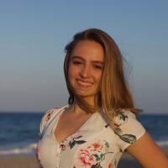
- Lauren Radesi, 2022 SURE Grant Recipient, "An Exploration of the Effectiveness of Virtual Reality Nature Based Therapy"
Mentor: Michael Eskenazi

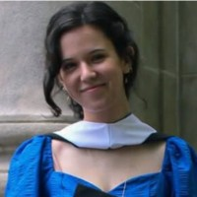
- Julia Gray, 2021 SURE Grant Recipient, “Social Media Usage and Conspiracy Theory Belief”
Mentor: Michael Eskenazi
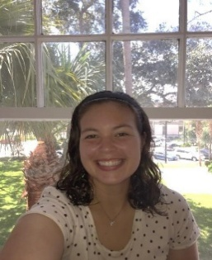
- Mackenzie Nalven, 2018 SURE Grant Recipient, "The Effect of
Limiting Email Usage on Job Productivity"
Mentor: Camille King
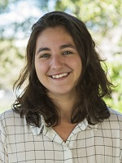
- Jozefina Logu, 2016 SURE Grant Recipient
"All About Pleasure": Potential User Responses to Female Condom Video
A sample of 570 participants recruited online completed evaluated a female condom promotional video and two different female condom packages.
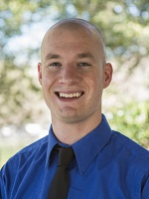
- Matthew Vanaman, 2016 SURE Grant Recipient, “Are you enlightened? Exploring the relationship between the enlightenment effect and the fundamental attribution error in evaluations of the homeless.”

- Jennifer Mondelli. 2016 SURE Grant Recipient
- Steven Pilato, 2016 SURE Grant Recipient
https://blog.stetson.edu/faculty-engagement/category/studentawards/

