● Julia Ramos de Camargo
Summer 2026 - Research Undergraduate Experience (REU) at Johns Hopkins
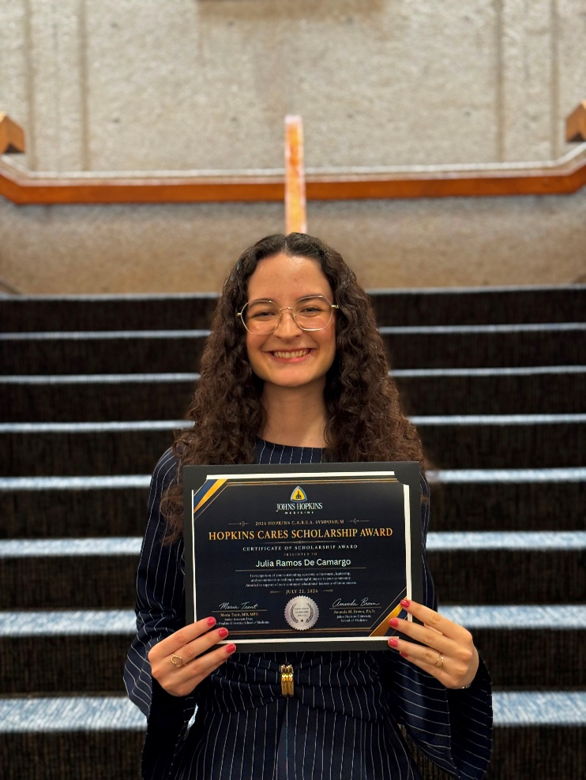
"In Summer 2026, I was selected to participate in the Johns Hopkins BSI-SIP, where I conducted Alzheimer’s disease research across research groups in the Departments of Biomedical Engineering and Neuroscience. My project investigated how amyloid-beta pathology may affect synaptic function, with a particular focus on the AMPA receptor subunit GluA2.
Throughout the summer, I gained hands-on experience with brain tissue processing, immunostaining, confocal microscopy, image analysis, and computational approaches to large datasets. I presented my research through both a scientific poster and an oral presentation and was also selected for the Johns Hopkins CARES Scholarship, receiving recognition for my work during the program.
One of the most meaningful parts of the experience was seeing how the skills I developed as a Psychology student at Stetson translated into a major research environment. My background in neuropsychology research, neuroscience coursework, and the Brain Fitness Academy helped prepare me to contribute confidently to Alzheimer’s disease research at Johns Hopkins.
This internship strengthened my interest in neuroscience and graduate research while showing me how far the opportunities and training available through Psychology at Stetson can extend beyond the classroom."

