SONA Research Participation Manual for Student Participants

SONA is the online research website that you will use to search for, sign up for, and participate in studies as a requirement or extra credit in your psychology classes.

This SONA manual will include all the information that you need to know for creating a participant account, signing up for studies, and assigning credits. Please read through this entire manual before you do anything with SONA. If you have any questions, they can be sent to the SONA administrator at ParticipantPool@Stetson.edu.

General Information 2
Participation
Cancellation and No-Shows
Requirements
Alternative Options
Deadlines

Requesting a New Account 3

Signing up For Studies 4

Assigning Credits to Classes 5

Cancelling a Study Timeslot 6

Alternative Assignment 7

SONA Research Participation Manual for Student Participants

Participation
Your participation in studies is extremely important and you should take participation very seriously. You are participating in real studies that your peers in Senior Project are conducting or studies that your professors are conducting as part of the research program.
Please keep track of the studies that you sign up for so that you do not miss any. It is helpful to show up at least five minutes early for each in-person study.
Your participation in all studies is voluntary and you can withdraw at any time. All studies have been approved by Stetson’s Institutional Review Board (IRB).

Cancelation and No-Shows
You can cancel your participation up to 24-hours prior to the study timeslot. If you fail to cancel your participation at this point, you will be marked as an unexcused no-show. If you accumulate 3 unexcused no-shows you will be locked out of the SONA system and will not be able to participate in any more studies.

Requirements
If you are a student in PSYC101S or PSYC203, you are required to participate in 6 SONA credits. If you are a student in PSYC211, PSYC221, PSYC231, PSYC241, PSYC242, or PSYC251, you are required to participate in 3 SONA credits.
These credits are part of your class grade. Each credit is worth 30 minutes of participation, and some studies will be worth more than one credit.
If you are participating in studies for extra credit in your classes, see your syllabus for information about how many you can participate in and how much extra credit each participation credit is worth.
Please note that you can only assign one credit to each class. If you are taking PSYC221, which requires participation, and PSYC498 which offers participation for extra credit, you must complete 3 credits for PSYC221 then any additional credits that you complete can be assigned to PSYC498 for extra credit.

Alternative Option
Most studies require participants to be at least 18 years of age. If you are not 18-years old or refuse to participate in research studies, you must complete the alternative assignment. Please see page 7 for information about the alternative assignment.

Deadlines
All study participations must be completed by Monday November 23rd.
All study credits must be assigned to classes by Wednesday November 25th.
The system will close on Wednesday November 25th, and all professors will be sent a final list of your participation credits.
You must let your professor know if you plan to complete the alternative assignment by Wednesday September 30th.
Alternative assignments must be turned in to your professor by Monday November 9th.

Requesting a New Account
**If you already have an account from previous semesters, do not do this, just log in**
Go to https://stetson.sona-systems.com/
Click on Request Account
You must enter your name, Stetson User ID (for example jsmith), phone number, and classes
Do not include @stetson.edu in your user ID
You must select ALL psychology classes that you are enrolled in. Be sure you select the correct section number!

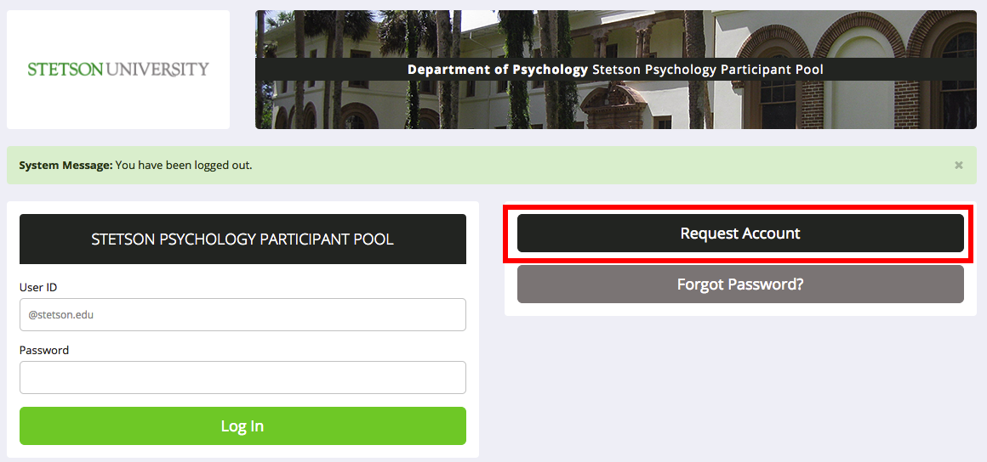

Frequently Asked Questions
What if I am not taking any psychology classes?
If you are not taking any psychology classes but want to participate in studies, you must select the NoPsychClass option under classes.

What if I do not have a phone number?
If you do not have a phone number or refuse to enter one, just enter 999-999-9999.

Why is my account not available yet?
You account must be approved by the administrator. The administrator will approve participants every few days. The administrator will not approve any studies over weekends. If more than five days pass without approval of your account, email the Administrator at participantpool@stetson.edu

What if I selected the wrong class or change sections?
If any of your classes change and you need to be reassigned, email the participant pool to request the specific change. Be sure to include the class number and section.

Signing up for Studies

Select the View Available Studies green box after you log in.

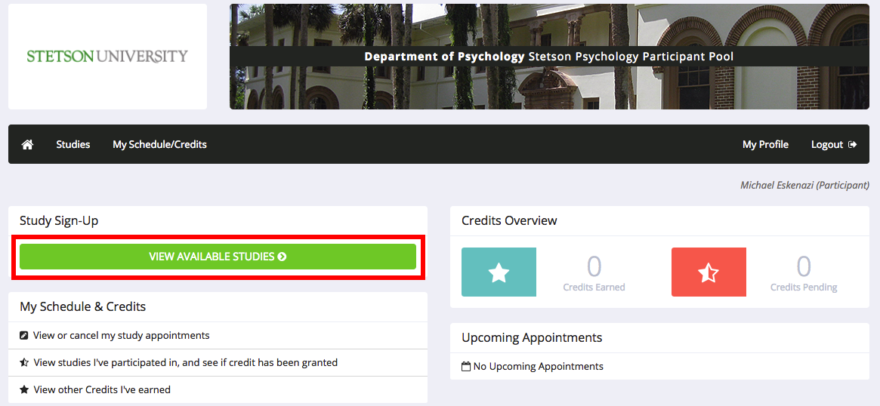

All available studies will be listed on the next screen. Read the description to decide if you want to sign up. Be sure to verify that you qualify for the study based on the requirements. Some studies will restrict age ranges, genders, or other factors.

When you see a study that you are interested in, select Timeslots Available.
A more detailed description of the study will appear, then select View Timeslots for This Study.
All of the available time slots will appear. Select whichever one best fits your schedule then press Sign Up.
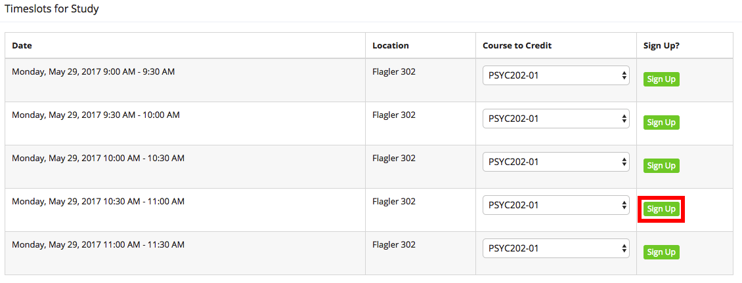

You will be emailed a confirmation of your sign-up and you will be emailed a reminder of your participation 24-hours prior to the timeslot.
After you participate in the study, the researcher will assign your credits within 48 hours.

Assigning Credits to Classes

After you participate in some studies, you will need to assign those credits to your classes. This is how you will get credit for participation. The professor of that class will get a report of student participation credits at the end of the semester. They can also monitor your progress throughout the semester.

As you earn credits, they will appear in the Credits Overview window in your home screen. Click on that credit to assign it to your classes.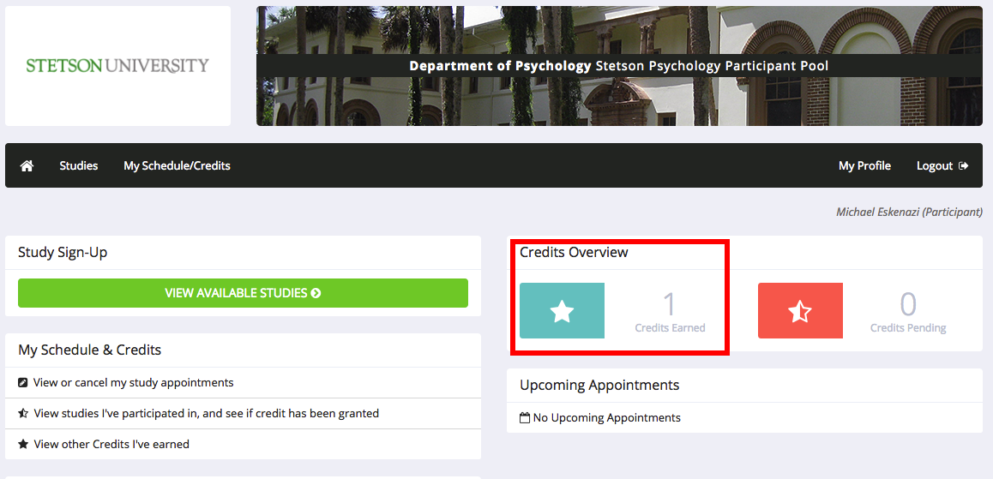

Credits will automatically be assigned to one class, but you can reassign that credit to a different class. If you are only taking one class, you do not need to do anything.

To reassign a credit, press Reassign, then select a different course, and press Reassign Credit.

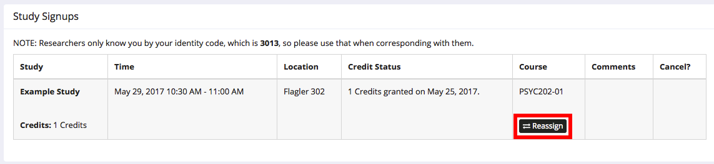

All of your credits must be assigned by the Wednesday November 25th! The system will freeze at that point, and you will not be able to change any of your credit assignments.

Cancelling a Study Timeslot

If you sign up for a timeslot but cannot attend the study, you must cancel your participation in the SONA system at least 24 hours prior to that timeslot.

To cancel your timeslot, select the study in the Upcoming Appointments window.

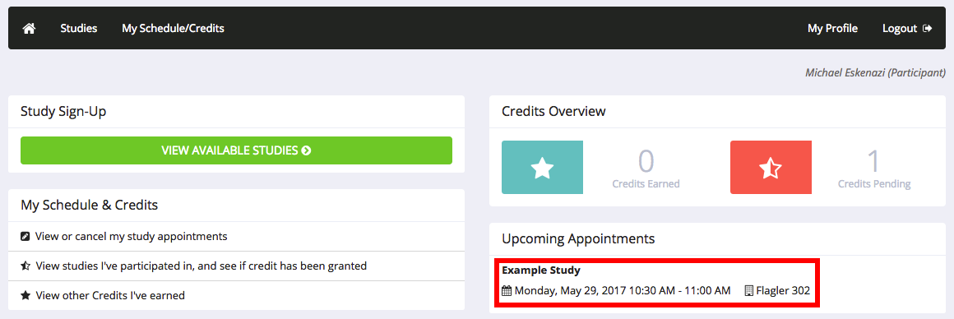

Then press cancel on the right side of the study and be sure to confirm your cancel on the next window that appears.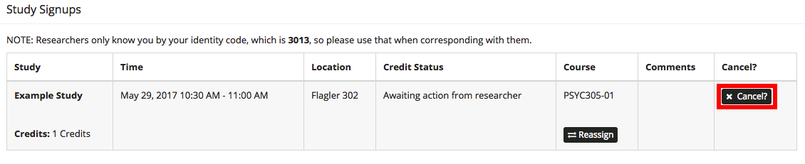

If you fail to cancel your participation 24-hours prior to participation, you will be marked as an unexcused no-show. When you accumulate 3 unexcused no-shows you will be locked out of the SONA system.

It is very important that you keep track of your scheduled timeslots so that you do not miss your studies. This is a huge inconvenience to the researcher and a waste of their time.

Alternative Assignment

Eligibility
If you are younger than 18 or refuse to participate in research studies, you may complete the alternative assignment. For the alternative assignment, you will find an empirical research article related to your class that you have not yet read and write an article summary.

How to Find an Article
To find an article, you can use PSYCInfo or Google Scholar. Go to PSYCInfo by following this link, and clicking on PSYCInfo: http://guides.stetson.edu/az.php?a=p
Go to google scholar by following this link: scholar.google.com
After you are in the database, you should use key terms to search for an article that is related to your class topics.

How to Write the Summary
After you find a good article, you should read it and summarize it. The summary must include relevant background information, the research question, expected results, brief methodology, main findings, and implications. Be sure to put everything in your own words, and do not copy anything or plagiarize directly from the article. Please ask your professor for more details.

Specifications and Deadline
Each article summary must be typed, double spaced, in 12-font, and in a typical font such as Times New Roman or Calibri. The length for each article summary must be at least one, but not more than two pages.

You must let your professor know if you plan to complete the alternative assignment by Wednesday September 30th.
Each article summary that you write will count for one research credit. So, if your class required seven research participation credits, then you must write seven article summaries.
All article summaries must be turned in to your professor by Monday November 9th, or at an earlier date specified by your professor.

