Process:

Step | Action
 | Navigate to https://my.stetson.edu/portal/index.jsp to log into my.stetson
 | The following tiles will appear for you to select from:
Click on the One Stop tile then hover over the down arrow on the Registration option:

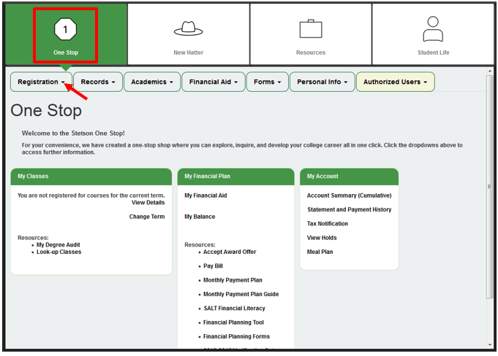

The following options will appear:
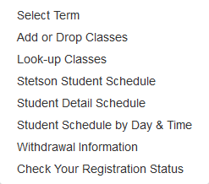

You can select any of these options depending on your task at hand.

 | Registrar Office – 386-822-7140 – registrar@stetson.edu
 | Bursar Office – 386-822-7050 – stuaccts@stetson.edu
 | Student Financial Planning – 386-822-7120 – finaid@stetson.edu

