Advanced Online Template Overview
The advanced online template includes the structure of the content you should post for all Fall 2020 courses that will be taught in a hybrid or fully online delivery. The contents are listed below as well as links to directions on how to upload and edit the template.
Press here to download the file containing the template. You must download the .zip file and upload to your Blackboard course shell(s) and edit as detailed below.
Contact OOLET at any time for assistance! We can upload template, provide training on any topic and assist with course development and higher level pedagogical options for quality course design.
NOTES:
- You must delete the duplicate or unused links that appear with the default Blackboard course shell.
- Dividers are included to help students navigate content with more ease.
- For detailed directions, logon to Blackboard > Organizations > Faculty Resource Center > Blackboard Basics > Online Course Template

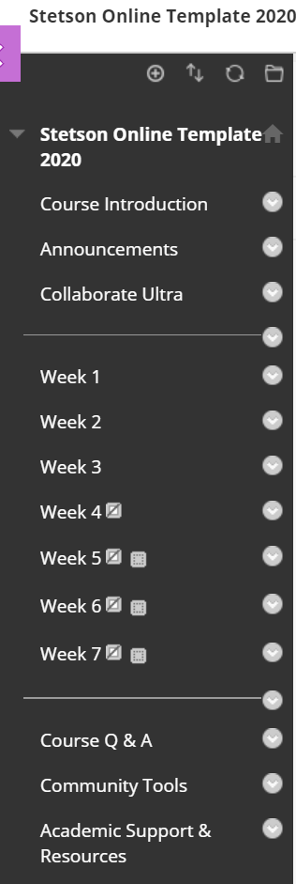
Contents
- Course Introduction
  - Course Welcome
  - Syllabus/Detailed Course Schedule (with assignments as appropriate). Syllabi should be consistent with University guidelines posted on: here.
  - Textbook & Other Required Course Materials
  - Browser FYI: provides information on which browser(s) works best with the content required in the course.
  - Online Learning Tips
- Course Announcements
- Conferencing Software Used in the Course (e.g. Collaborate Ultra, Teams, or Zoom)
DIVIDER
- Weekly Content
  - Learning Objectives
  - Required Reading
  - Lecture Content
  - Interactive Tools
  - Assignments / Assessments
  - Weekly Summary
DIVIDER
- Course Q & A
- Course Tools
- Academic Support & Resources
Blackboard Instructions
Import Course Template / Package
Create Navigation Menu Links
Add Content
Edit Content

