Basic Template Overview
The basic template includes the minimal amount of content you should post for all Fall 2020 courses that will be taught in a traditional classroom with lecture capture and/or conferencing technology. The contents are listed below as well as links to directions on how to upload and edit the template.
Press here to download the file containing the template. You must download the .zip file and upload to your Blackboard course shell(s) and edit as detailed below.
Contact OOLET at any time for assistance! We can upload template, provide training on any topic and assist with course development and higher-level pedagogical options for quality course design.
NOTES:
- You must delete the duplicate or unused links that appear with the default Blackboard course shells. Since the Fall 2020 course were created months ago, there was no way to automatically upload this template.
- Dividers are included to help students navigate content with more ease.

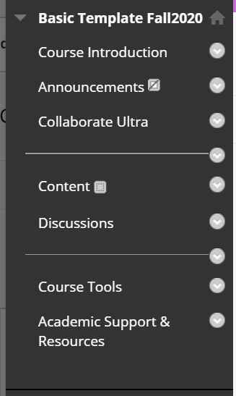
Basics Template Contents
- Course Introduction
  - Course Welcome
  - Syllabus/Detailed Course Schedule (with assignments as appropriate). Syllabi should be consistent with University guidelines posted on: here.
  - Textbook & Other Required Course Materials
  - Browser FYI: provides information on which browser(s) works best with the content required in the course.
  - Online Learning Tips
- Course Announcements
- Conferencing Software Used in the Course (e.g. Collaborate Ultra, Teams, or Zoom)
DIVIDER
- Content
- Discussion
DIVIDER
- Course Tools
- Academic Support & Resources

Blackboard Instructions
Import Course Template / Package
Create Navigation Menu Links
Add Content
Edit Content

