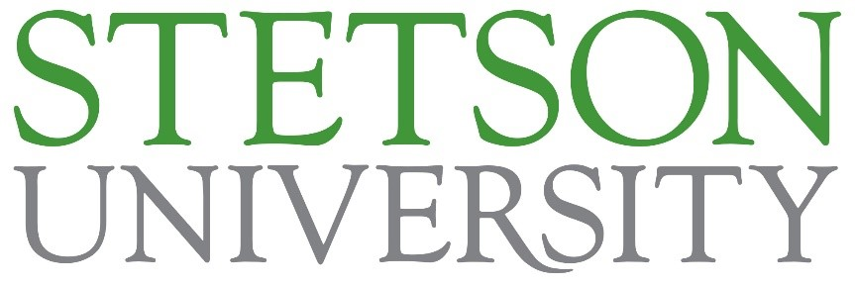

Dean, College of Arts and Sciences
Stetson University
DeLand, Florida

Our mission at Stetson University is to provide an excellent education in a creative community where learning and values meet, and to foster in students the qualities of mind and heart that will prepare them to reach their full potential as informed citizens of local communities and the world.

THE SEARCH

Stetson University seeks an enthusiastic and visionary leader as its next Dean of the College of Arts and Sciences (herein “the College”). Stetson, an institution rooted in “relationship-rich” education, is one of the top regional comprehensive institutions in the nation and is on a path to greater achievement and distinctiveness as a student-centered, innovative institution. Stetson has made strategic investments in academics and student success to further establish the university as an influential force in educating future leaders. The dean will join a leadership team that is defining a bold new chapter for the institution, and the College will be critical in this effort. The dean will harness the disciplinary diversity of the College to establish a vision for its future direction and will advocate for the vital role of liberal arts and sciences in modern higher education.

Located in the heart of Central Florida, Stetson University was founded in 1883 by New York businessman Henry A. DeLand, and later named for John B. Stetson, the nationally known hat manufacturer from Philadelphia who gave generously to advance the academic excellence of the institution. Stetson University enrolls 2,339 undergraduates and 1,331 graduate and professional students in its four colleges and schools: College of Arts and Sciences, College of Law, School of Business Administration, and the School of Music across its three Florida campuses. Additionally, Stetson maintains a rich array of university centers and institutes. Stetson emphasizes the importance of an education grounded in liberal learning, with practical experiences infused in its programs, culture, and community. The College is a core part of the university with nearly 1,700 students and approximately 160 full-time faculty across 19 academic departments and several interdisciplinary programs. As the leader of the largest academic unit, the dean will have a unique opportunity to lead a broad and comprehensive organization, provide intellectual leadership to dedicated faculty and staff, and develop innovative strategies for academic programs and student engagement.

The dean will be visible and engaged in the university community and will possess a dynamic leadership style that inspires faculty, students, staff, and alumni to collaborate in the development of a shared vision for the future. Stetson seeks an accomplished scholar and administrator with a track record of success in academic administration and with an understanding of and a commitment to private higher education.

Stetson University has retained Isaacson, Miller, a national executive search firm, to assist in this recruitment. All applications, inquiries, and nominations, which will remain confidential, should be directed to the search firm.

TO APPLY

Inquiries, nominations, referrals, and applications that include CVs with letters of interest should be sent via the Isaacson, Miller website for the search. Electronic submission of materials is strongly encouraged.

For timely and comprehensive consideration, applicant materials should be received no later than January 12, 2024. Application reviews will begin immediately and continue until the completion of the search process.

Pam Pezzoli, Partner
Debbie Scheibler, Senior Associate
Melissa Barravecchio, Search Coordinator
Isaacson, Miller

To apply, please visit: https://www.imsearch.com/open-searches/stetson-university/dean-college-arts-and-sciences

Electronic submission is strongly encouraged.

Stetson University is an Equal Opportunity Employer that affirms cultural diversity and inclusion as a core value of academic excellence at Stetson University. We are committed to achieving equal access in education, employment, and participation through the recruitment and retention of outstanding faculty, staff, and students from diverse backgrounds, and to meaningful academic and intellectual transformation in curriculum, research and service. We are dedicated to actions and policies that foster a community in which individuals with various identities, cultures, backgrounds, and viewpoints work together to create opportunities for engagement through rewarding and fulfilling careers and personal experiences in a culturally and racially diverse society and a globalized world. We strongly encourage members of historically under-represented and economically disadvantaged groups and women to apply for employment. Stetson University is an EEO, ADA, ADEA, and GINA employer.

