Self-Selection Guide
for Continuing Students
2022-2023
IMPORTANT 2022 DATES TO REMEMBER
February 1 Continuing Student Applications are available on Housing Central
- Housing Application
- Request for Residency Exemption
- Request for Special/ADA Accommodation
- Request for Animal-in-Residence
February 18 Returning Student First Priority Deadlines:
- Housing Application
- Request for Special/ADA Accommodation
- Request for Animal-in-Residence
- Request for Residency Exemption

March 1 2nd Priority Deadlines:
- Housing Application
- Request for Special/ADA Accommodation
- Request for Animal-in-Residence
- Request for Residency Exemption
March 14 Priority Deadlines:
- Greek Living
- Living Well
- Russian House (245)
- Conrad
April 1 Priority Deadlines:
- New student priority
- Final Continuing to Participate in Self-Selection

April 11 - 15 New/Transfer Student Housing Self-Selection
April 19 - 22 Continuing Student Housing Self-Selection
May 15 Last day to cancel room assignment for Fall 2022 with a $500 cancellation fee
May 16 – August 14 Room assignment cancellations for Fall 2022 will be assessed a $1000 cancellation fee
August 14 Residence Halls open for Continuing Students
August 18 Fall 2022 room assignment cancellation fee increases to full semester rent

RESIDENCY EXEMPTION REQUESTS
Stetson maintains a three-year residency requirement, meaning all undergraduate students must live in university housing for the first three years of their enrollment at Stetson. All students that HAVE NOT satisfied the three-year residency requirement must submit a Housing Application requesting to live on campus.

However, if a student HAS NOT satisfied the three-year residency requirement, but wishes to live off campus, the student must request an exemption to the residency requirement by submitting the Request for Residency Exemption found on the Housing Central Home page. An exemption will only be granted if the student meets at least one of the following exemption criteria:

• The student has earned 22 units (90 credits) or more by August 1, 2022
• The student is at least 22 years of age by August 1, 2022
• The student is married or in a domestic partnership
• The student will Reside within a 45 mile radius of the university with immediate or extended family.
Photo ID with local address is required by the family member. Immediate Family is defined as parent, legal guardian. For extended family member, the Parent/Guardian must also provide a notarized letter verifying the relationship of the extended family member to student. Extended family is defined as grandparent, aunt/uncle, sibling not attending Stetson.
• The student is participating in a University-approved, off-campus internship/program that requires the student to live outside the local area.

Students that do not meet any of the above exemption criteria may request an exemption based on an exceptional and compelling individual circumstance that cannot be accommodated within campus housing.

STUDENTS WHO ARE GRANTED A RESIDENCY EXEMPTION WILL NOT BE ALLOWED TO PARTICIPATE IN THE HOUSING SELF-SELECTION PROCESS

Deadline for Request for Residency Exemption:
This request does not have a traditional “deadline”. A student may submit a Request for Residency Exemption at any point, but there are critical dates related to process timelines and cancellation fees. Please see an explanation of the “deadlines” below to understand the "Due Date" on your Housing Central homepage. For more information regarding the cancellation schedule, refer back to your Residential Living & Learning Housing Agreement 2022-2023, Section VI. Cancellation and Refund Information, Letter C, D, & E.
HOUSING RATES FOR FALL 2022 – SPRING 2023
2022-2023 Housing Rates – DeLand Campus
Rate Type | Semester
Shared Bedroom - Community Bathroom | $3,852
Shared Bedroom - Suite/Private Bathroom & Houses A-F, 1-7 | $4,194
Individual Bedroom - Community Bathroom | $4,284
Individual Bedroom - Suite/Private Bathroom & Houses | $4,590
Shared Bedroom - Apartment | $4,698
Individual Bedroom - Apartment | $5,124
Summer Housing Rate: $145 per week/$2030 for Full Summer Housing

ASSIGNMENT CANCELLATION TIMELINECANCELLATION FEE Timeline
Deadlines | Explanation | Fee
On or Before  May 15 | All continuing students WITH A HOUSING ASSIGNMENT that submit and are approved for a residency exemption will be assessed a cancellation fee. | $500
On or after May 16 | All continuing students WITH AN ASSIGNMENT that submit and are approved for a residency exemption will be assessed a cancellation fee. | $1,000

Students requesting cancellation of their Housing Agreement that DO NOT have a housing assignment, will not be assessed a cancellation fee. Please note that students can be provided an assignment at any time, so please submit your cancellation requests ASAP.

REQUEST FOR SPECIAL/ADA ACCOMMODATIONS
Students who would like additional consideration in the housing assignment process or that require specific housing arrangements based on a special/ADA need, must submit the Request for Special/ADA Accommodation found on the Housing Central Home Page.

These requests include but are not limited to a housing assignment:
- to a specific area of campus (i.e. close to the center of campus)
- to a specific area of the residential building (i.e. first floor, close to the bathrooms/kitchen, etc.)
- to a specific room type (shared/individual/apartment)
- to a specific bathroom type (community/semi-private/private)
- with a specific resident that can provide support and assistance to the student

An accommodation can also include a reasonable modification made to an assigned space. For example, a full-size bed, a hand-held shower head, a doorbell for the sight-impaired, etc.

NOTE: Students requesting to live with their Emotional Support Animal or Service Animal DO NOT need to submit a request for accommodation. To request to live with an Emotional Support Animal or Service Animal, the student must submit the Request for Animal-in-Residence only.

Priority Deadline to Submit: March 1, 2022
Accommodation requests can be submitted at any time prior to the start of the housing agreement period or during the housing agreement period.
However, it is recommended that requests be submitted by the priority deadline of March 1 to ensure the greatest chances of receiving an assignment that meets your needs, as there are a limited number of spaces available in each residential building, room type, bathroom type, etc.
Students that submit an accommodation request by the priority deadline and receive approval for their request will be provided with a housing assignment prior to the Housing Self-Selection process and therefore will not participate in the selection process.

Required Documentation
All requests for special/ADA accommodation require documentation outlining the specific needs of the student in regards to their housing environment. Documentation must also provide a rationale for requesting the specific housing arrangements. Specific documentation may vary based on the type of accommodation requested.

Documentation must not be more than three years old. If documents are older than three years old, the student will be asked to provide updated documents.

NEW vs. RENEWAL Accommodation Request
While completing the Request for Special/ADA Accommodation on Housing Central, students will be asked if their requested accommodation is a NEW request or a RENEWAL request.

A NEW Accommodation Request is one that has not been provided/approved by Residential Living & Learning in the past semesters living on campus. NEW Accommodation Requests require updated documentation for the new request.

Your request for accommodation is NEW if:
- You are a continuing student who HAS NOT been provided with an accommodation in the past, but would like to request one now
- You are a continuing student who HAS been provided with an accommodation in the past, but your needs have changed

A RENEWAL Accommodation Request is one that has been provided/approved by Residential Living & Learning in the past semesters living on campus and the request has not changed. RENEWAL Accommodation Requests do not require updated documentation provided that the documentation on file with Residential Living & Learning is no more than three years old.

Your request for accommodation is a RENEWAL if:
- You are a continuing student who has been provided with an accommodation in the past and your requested accommodations HAVE NOT CHANGED

Roommate Requests
Students requesting a special/ADA accommodation will be permitted to request one roommate. Roommate requests cannot be guaranteed and will be granted based on availability of space and the existence of a Roommate Group. The student requesting the accommodation and their preferred roommate must form a Roommate Group in Housing Central to confirm that they wish to live with one another.

REQUEST FOR ANIMAL-IN-RESIDENCE
Students that would like to request to live with their animal in the residential buildings must submit a Request for Animal-in-Residence on the Housing Central Home Page and receive official approval from Residential Living & Learning before bringing the animal to campus.

There are four different categories of Animals approved by Residential Living & Learning; Pets, Emotional Support Animals, Service Animals, and Service Dogs-in-Training. Pets and Service Dogs-in-Training will only be approved to live in Animal-Friendly Housing. Emotional Support Animals and Service Animals are permitted to live in any residential building in accordance with Federal Fair Housing Laws.

Community Standards Reminder
- If a student is living with an unapproved animal in the residential buildings, the student will be subject to a $500.00 unapproved animal fine and required to participate in a conduct hearing, which could result in additional sanctions.
- If a student is found to have an unapproved animal “visiting” their residential building, even if the animal is approved for another resident, the student will be subject to a $100.00 unapproved animal fine and required to participate in a conduct hearing, which could result in additional sanctions.

Animal-Friendly Housing Locations
Stetson offers three Animal-Friendly Housing locations; University Hall, Stetson Cove, and the 300 Building of University Village Apartments. While Pets and Service Dogs-in-Training are the only category of animal required to live in Animal-Friendly Housing, we encourage all students requesting to bring an animal to campus to preference Animal-Friendly Housing locations on their Housing Application and attempt to assign themselves to one of the three Animal-Friendly buildings during Housing Self-Selection.

Priority Deadline to Submit: March 1, 2022

ALL GENDER HOUSING
Rooms/suites/apartments can opt-in to be all gender to allow students to live with other students regardless of gender similarity or difference. All Gender Housing is available for students who do not wish to live in a room/suite/apartment that aligns with a binary view (male/female) of gender identities or may not feel comfortable in a traditionally gendered environment.
Residents who choose this option will have varied understandings of gender, gender identity and gender expression.
Examples of students who may be interested in All Gender Housing include, but not limited to:
- Students who identify as transgender or gender non-conforming requesting a roommate based on comfort and support rather than biological sex (i.e., friend or ally);
- Allies and all students seeking a mixed gender housing option.
Note that no student will be placed in an all gender room/suite/apartment unless the student gives consent to do so.
FRATERNITY AND SORORITY ASSIGNMENTS
All fraternities and sororities presidents have been asked to submit a fall roster of affiliated members for their respective houses. If you are one of these individuals included on this roster, you must submit the Returning Student Application 2022-2023 and confirm your desire to live in fraternity and sorority housing. (Just because your house manager or chapter president adds you to the roster does not mean you can skip this step of the process.)
Each president is to submit a roster with the roommate pair for each room in the house by March 14. If your name is on this roster, you WILL NOT be able to participate in the Room Selection Process.

STUDY ABROAD PARTICIPANTS
If you are planning to study abroad fall semester, you must complete the Residency Exemption Request 2022-2023 - Fall.

- If you are also requesting to live off campus for the Spring 2023, you’ll need to indicate this on the form, as well. Be sure to check the Fall and Spring box on the form as opposed to Fall Only.

- All students returning from study abroad who have not yet met the University Residency Requirement will be expected to return to campus and continue to reside in University housing.

- If you are planning to live on campus for Spring 2023, you will need to submit the Returning Student Application 2022-2023 – Spring in the fall semester. Applications should be available no later than October 1, 2022.

HONORS AND BONNERS HOUSING
The Honors and Bonner Programs are housed in Conrad Hall. If you are a member of either of these programs, you will not be able to sign up through Room Selection.
If you would like to live with other members of the Honors Program, you need to contact Dr. Melinda Hall, Co-Director of University Honors, phone# 386.740.2507, email: mchall@stetson.edu
If you would like to live with other members of the Bonners Program, you will need to contact Kevin Winchell, Associate Director of Community Engagement, phone# 386.822.8705, email: kwinchel@stetson.edu
RESIDENTIAL LEARNING PROGRAMS RESIDENTIAL COMMUNITIES
Residential Living and Learning offers unique theme based residential communities for continuing students:
· Living Well (Conrad)
· Women’s Leadership (Chaudoin, 2nd North)
· Honors & Bonner (Conrad)
· 24-hour Quiet Floor (3rd Main, Emily)
· Community Catalyst House - Russian

Community Catalyst Houses are residential locations in which students can create small spaces where they can establish their own community and support Stetson’s overall core values. For students living in one of these communities, peer engagement with other students and with the Stetson community are key. It will also be a great place to become well-acquainted with a faculty member outside the traditional classroom setting. Ask your RA or RLC to provide you with more information about our Catalyst Houses being offered this fall.

ROOM SELECTION PROCESS
Please review the information noted below very closely.

SELECTION PRIORITY
- Selection priority will be determined by accumulated earned credit hours and GPA.
  - Remember that earned credit hours are credits that you have ALREADY accumulated in previous semester(s) (by December 31, 2021). The credits that you are currently earning in the Spring semester are not considered in this process. The same holds true for GPA.
- The selection appointment time for a group will be based on the average credit hours/GPA of all members of the group.

PHASES I, II, AND III
The Room Selection process is designed to allow more students to be able to live with preferred roommates. Phase I and Phase II are designed for roommate groups to completely fill the selected room/apartment. Individuals without a roommate preference may participate in Phase III to select individual spaces remaining in the process.
PHASE I
In Phase I, you will need a three- or four-person group to fill the spaces available. Spaces offered during Page 1 include three-person and four-person apartments in Stetson Oaks and University Village (not including Maxcy), and four-person suites in Emily and Chaudoin.
Students who participate in Phase I and are unable to obtain a four- or three-person apartment/suite may reconfigure their group into two-person roommate pairs to participate in Phase II.
PHASE II
In Phase II, you will need to be in a two-person roommate pair to select a room/apartment in Stetson Palms, Stetson Cove, Stetson Oaks, Maxcy Hall, Emily, Chaudoin, University Hall, Hatter, and Nemec.
Students who participate in Phase II and are unable to obtain a two-person room/apartment may opt into Phase III to select an individual space.
PHASE III
In Phase III, all spaces remaining will be made available for individuals who do not have a roommate preference or those that were unable to select a space during Phase I & II.

PHASE I & II ROOM SELECTION STEP BY STEP INSTRUCTIONS
1. APPLY. Submit your Returning Student Application through Housing Central by the priority deadline April 1.

2. PLAN AHEAD. Think about where and with whom you want to live. Talk to people and make plans and multiple back up plans in case your preferred building or room type is not available when you make your selection.

3. FORM YOUR ROOMMATE GROUP. Creating your roommate group in Housing Central is easy. Remember that all individuals in the roommate group must have submitted a housing application and been approved. If not, they will not be able to participate in the Room Selection process until this step is complete.

To form your group, follow the steps below:
· Log into Housing Central
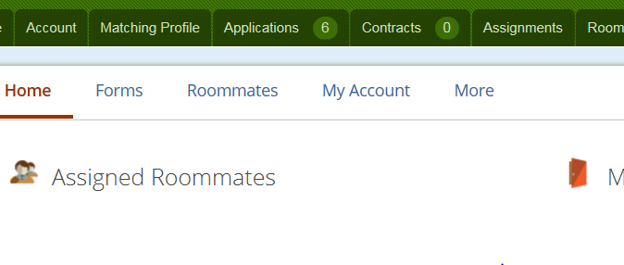
· Click on the “Roommates” tab at the top of the screen

· Select the Fall 2022 Semester
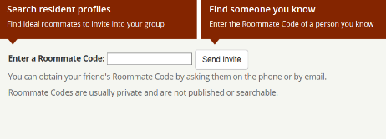
· Click on the “Find Someone You Know” box

· Enter the roommate code of the resident(s) with whom you are interested in living. You must contact your preferred roommate to ask for their roommate code.
Roommate codes can be found at the top right of the Housing Central screen under a resident’s name.
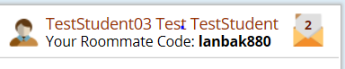

Remember: Only share your roommate code with those whom you are interested in living.
· Your roommate group must be the exact same size as the space you are selecting.
Example: 4 people for a 4-bedroom apartment, 2 people for an adjoining Hatter singles, 2 people for a suite-style bath in Emily, etc.

· Once you have entered in your friend’s roommate code, a message will be sent to them with an invitation to be your roommate.
· Your friend will log into Housing Central and see a message icon at the top right corner indicating that a roommate invitation has been received.
· Your friend will click on the roommate invitation. If your friend accepts, then they will respond to the invitation and click “Send.” If your friend is not interested, then they will select “Cancel.”
· Please keep in mind, if the roommate invitation is not accepted or responded to, the roommate pairing is not complete. RL&L suggests that if someone is not responding or playing the roommate field, move on and find some else. You deserve better!

4. Designate who in the group will be the group leader. The group leader will be the one who enters into the room selection process to select the room and can be ANY member of the group. (Initially, the group leader is defaulted to the resident who sends out the roommate group invitations). The resident assigned as the group leader is the only one who can change the group leader status.
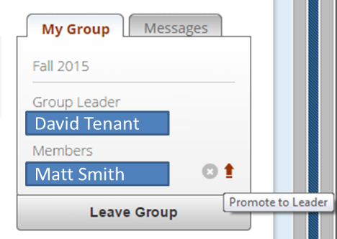
If you need to change the group leader:
· Have the current roommate group leader log into Housing Central, find the roommate group under the roommate tab and then select the Fall 2022 semester.
· The roommate group that the residents belong to is located on the right side of the screen. Scroll over the name of the resident you want to make group leader.
· An arrow will appear next to the name. Click on that arrow to promote that roommate to become group leader.

5. SELECT A SPACE. Once your room selection time has arrived, the Group Leader logs into Housing Central, finds available rooms through the “Make Room Selection” area of the “Room Selection” tab, and selects the group’s housing assignment.
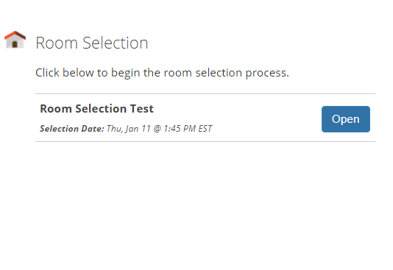
Please know that the group leader may make your selection at any point after your selection time begins if it is before roommate groups are locked prior to the beginning of the next phase of the process, so if no one in your group is available to be the leader at your selection time, you can relax knowing you can still select when your group leader becomes available.
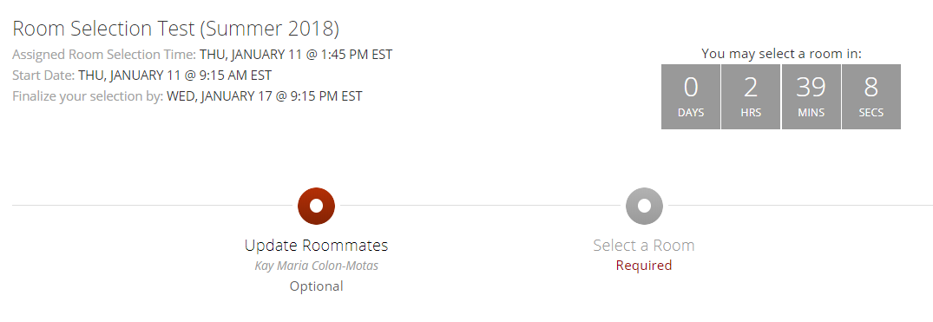
Group Leader will then see the countdown clock at the top of the next screen. In this example the student has 2 hours, 39 minutes, and 8 seconds until they can enter the portal to select a room. However, prior to this, students can review available rooms and note or favorite them so that they will be quickly selected once the portal opens.

SELECT A SPACE (CONT.)
To review rooms prior to your selection start time, students can select criteria and search for a room using these filters.
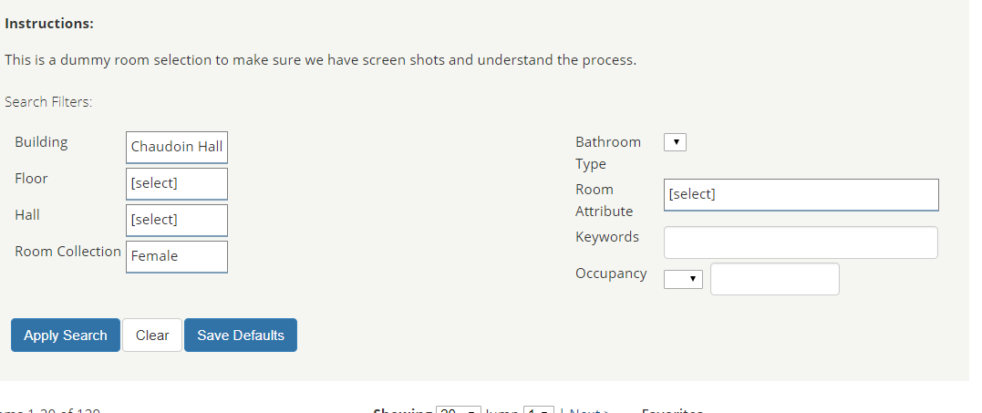
Once the student is satisfied with their search parameters, hit the “Apply Search” and the results appear on the next screen.

Students can then see the rooms available that fit into the parameters they selected. The rooms with a Blue Open Room button are available for selection, the rooms with a White Open Room Button have been filled by people who may have had earlier appointment times.
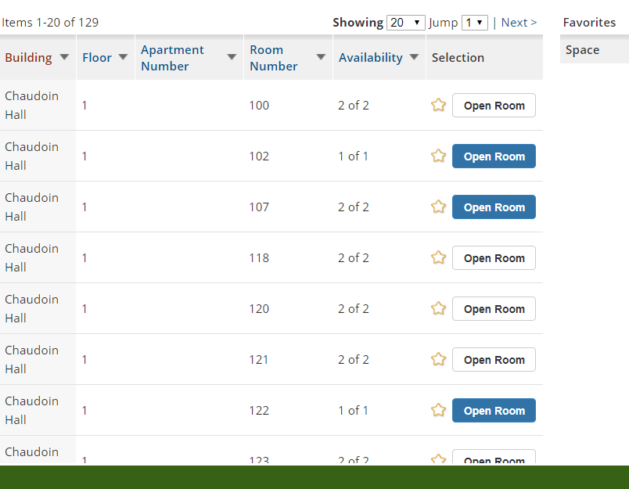
Not Available
Available

SELECT A SPACE (CONT.)

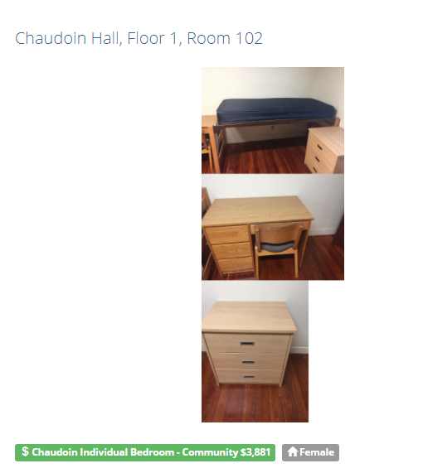
When the “OPEN ROOM” button is clicked, the room description, amenities and pictures of furniture are provided.
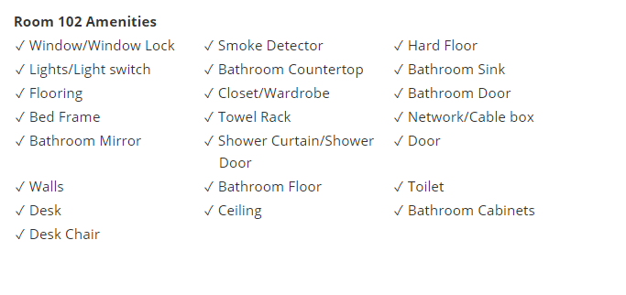

Once a student has viewed this information and thinks this is a possibility for next year, then they can mark it as a Favorite by clicking the star.

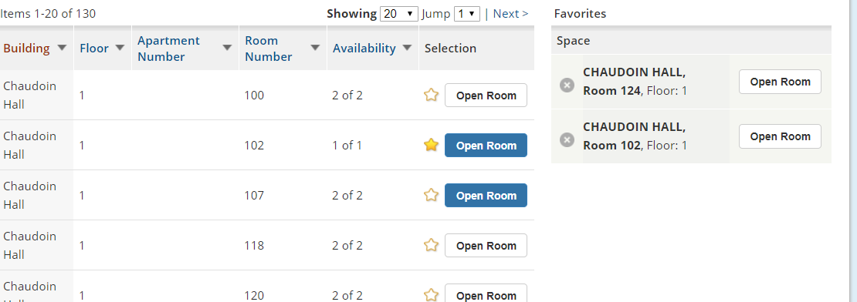

When the Countdown Clock reaches zero, the Clock then begins to indicate how much time is left in this phase of the room selection process.

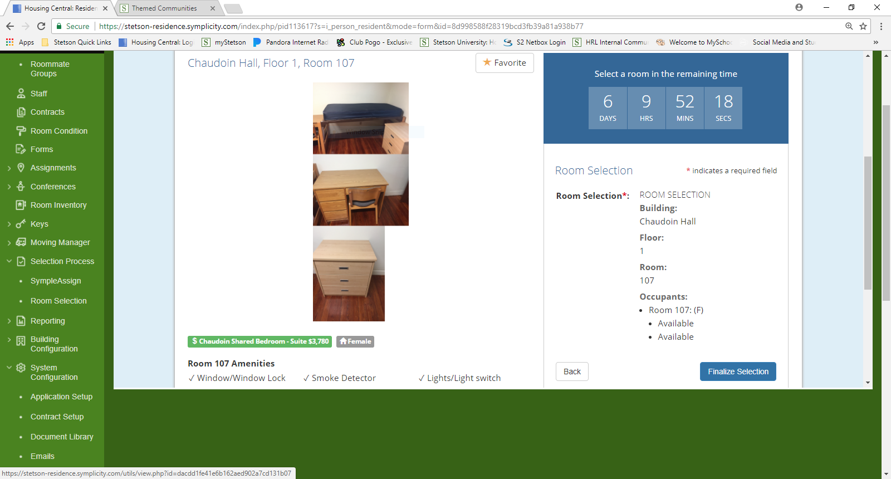

When the group leader has identified an available room that they would like to select and reserve for themselves and their roommates, they must click the “OPEN ROOM” button and the “FINAILIZE SELECTION” button. Then they must confirm their selection by clicking OK on the pop-up confirmation box, which will finalize the room selection.
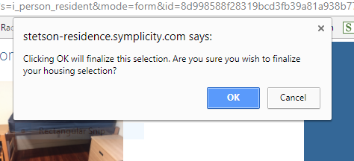

SELECT A SPACE (CONT.)

The next screen will provide a confirmation of the room selected.
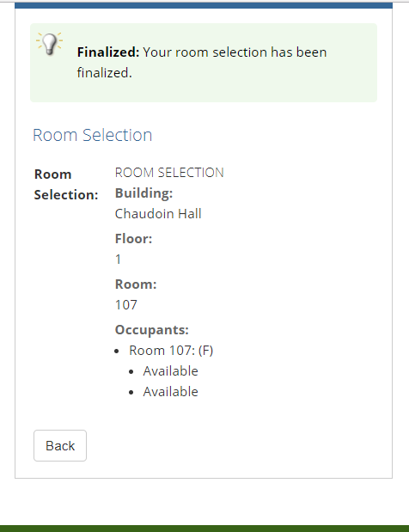

All students in the roommate group will now see their room selection on the Home section of their Housing Central account.
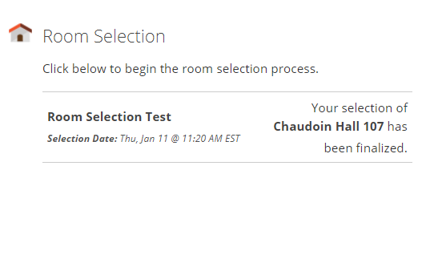

PHASE III ROOM SELECTION STEP BY STEP INSTRUCTIONS
1. APPLY. Submit your Returning Student Application through Housing Central by the priority deadline April 1.
2. PLAN AHEAD. Think about where you want to live. Make plans and multiple back up plans in case your preferred building or room type is not available when you make your selection.
3. SELECT A SPACE. Once your room selection time has arrived, you may log into Housing Central, find available rooms through the “Make Room Selection” area of the “Room Selection” tab, and select your housing assignment.
You will then see the countdown clock at the top of the next screen. In this example the student has 2 hours, 39 minutes and 8 seconds until they can enter the portal to select a room. However, prior to this, students can review available rooms and note or favorite them so that they will be quickly selected once the portal opens.

To do so, students can select criteria and search for a room using these filters.

Once the student is satisfied with their search parameters, hit the “Apply Search” and the results appear on the next screen.

Students can then see the rooms available that fit into the parameters they selected. The rooms that are indicated in Blue are available for selection, the other rooms have been filled by people who may have had earlier appointment times.
Available
Not Available

When the “OPEN ROOM” button is clicked, the room description, amenities and pictures of furniture are provided.

SELECT A SPACE (CONT.)

Once a student has viewed this information and thinks this is a possibility for next year, then they can mark it as a Favorite by clicking the star.

When the Countdown Clock reaches zero, the Clock then begins to indicate how much time is left in this phase of the room selection process.

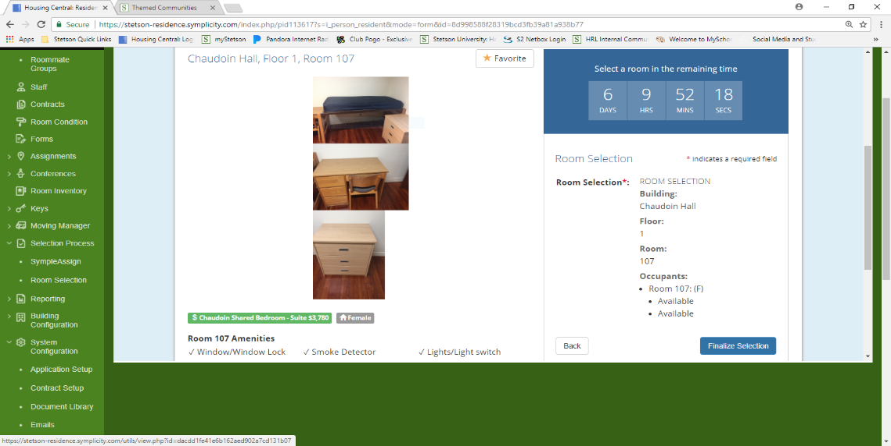
SELECT A SPACE (CONT.)

When you have identified an available room that you would like to select and reserve for yourself, you must click the “OPEN ROOM” button and the “FINAILIZE SELECTION” button. You must confirm your selection by clicking OK on the pop-up confirmation box, which will finalize the room selection.

The next screen will provide a confirmation of the room selected.

SELECT A SPACE (CONT.)

You will now see your room selection on the Home section of your Housing Central account.

In order to change the selected room, follow all steps provided in the room selection process.

