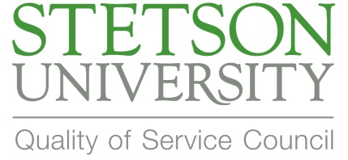

2014 Employee Recognition Award Nominees

- Al Allen
- Albert Aguirre
- Amy Dedes
- Amy McAfoos-Schaeffer
- Ana Maia
- Ann Molohon
- Becky Stone
- Bill Noblitt
- Bob Matusik
- Brian Johnson
- Cadi Poage
- Cameron Edwards
- Candi Thompson
- Caroline Skinner
- Charles Knott
- Cheryl Stadtler
- Christine Martin
- Cindy Oakely-Paulik
- Colin MacFarlane
- Colleen Price
- Debbie Tate
- Dee Carpenter
- Ednan Saez
- Gary Sipe
- James (Jimmy) Kelly
- Jamie Vanderlip
- Jan Batchelder
- Juana Delgado
- Julie Houser
- Kendrial Wilson
- Kevin Miller
- Laura Glander
- Linda Zack
- Lisa Guenther
- Lynn Schoenberg
- Melissa Fleming
- Melissa Peters
- Michele Clifton
- Nancy Kernan
- Nita Ellis
- Nolan Behrns
- Pam Clayton
- Paul Gleason
- RC Stabile
- Rebecca Stone
- Rina Arroyo
- Robert Andrews
- Sandee Farrington
- Sandy Lenholt
- Savannah Griffin
- Sidney Johnston
- Stacy Turner
- Tanner Vickers
- Tara Jones
- Vikram Ahmed
- Yolany Gonell

