Logging Into MAP-Works
Faculty have two options for logging into MAP-Works.
- Log in through Blackboard
- Log in directly to MAP-Works

Blackboard
Log into Blackboard using your network username and password. On your home page, go to the Tools module and find MAP-Works in your list.
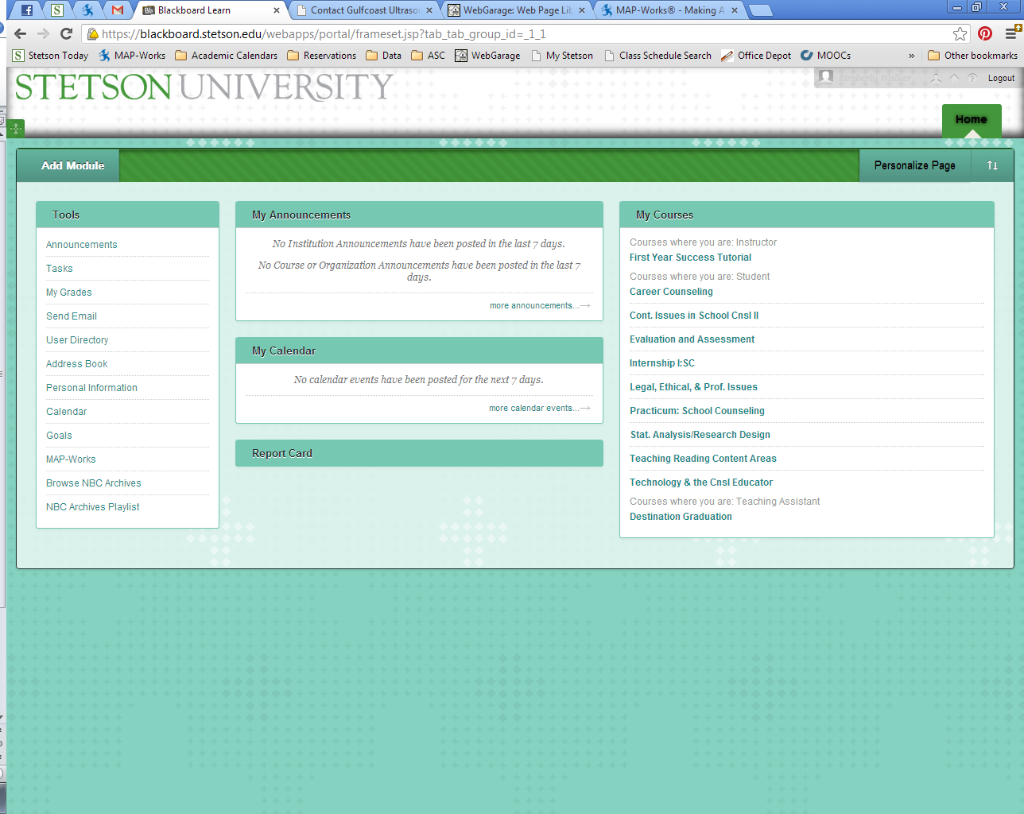
Selecting MAP-Works will bring you to an intermediate page. Follow the link to continue on to the full MAP-Works Site.
This option automatically logs you into MAP-Works. Similarly, students can log in to their MAP-Works accounts through Blackboard.

Direct Log in
If you prefer to log in directly, bookmark http://stetson.map-works.com for easy access to the site. On the log in page you will use your network username and password (same as your Email and Blackboard log in). Be sure you log in on the Faculty/Staff side of the access page.

Faculty MAP-Works Home Page
The first time you log into MAP-Works, you will be required to review and accept the confidentiality statement. Then, a Welcome to MAP-Works video will appear. If you do not want to view the video at this time, you can close the screen. Informational videos are available throughout MAP-Works at the lower left corner of each page.

Input Only
Your Input Only home page has a few different options, but you cannot view any information about students. We will review these capabilities later in this guide.

Direct-Connect
The Direct-Connect homepage has additional information related to the viewing capabilities of the user.
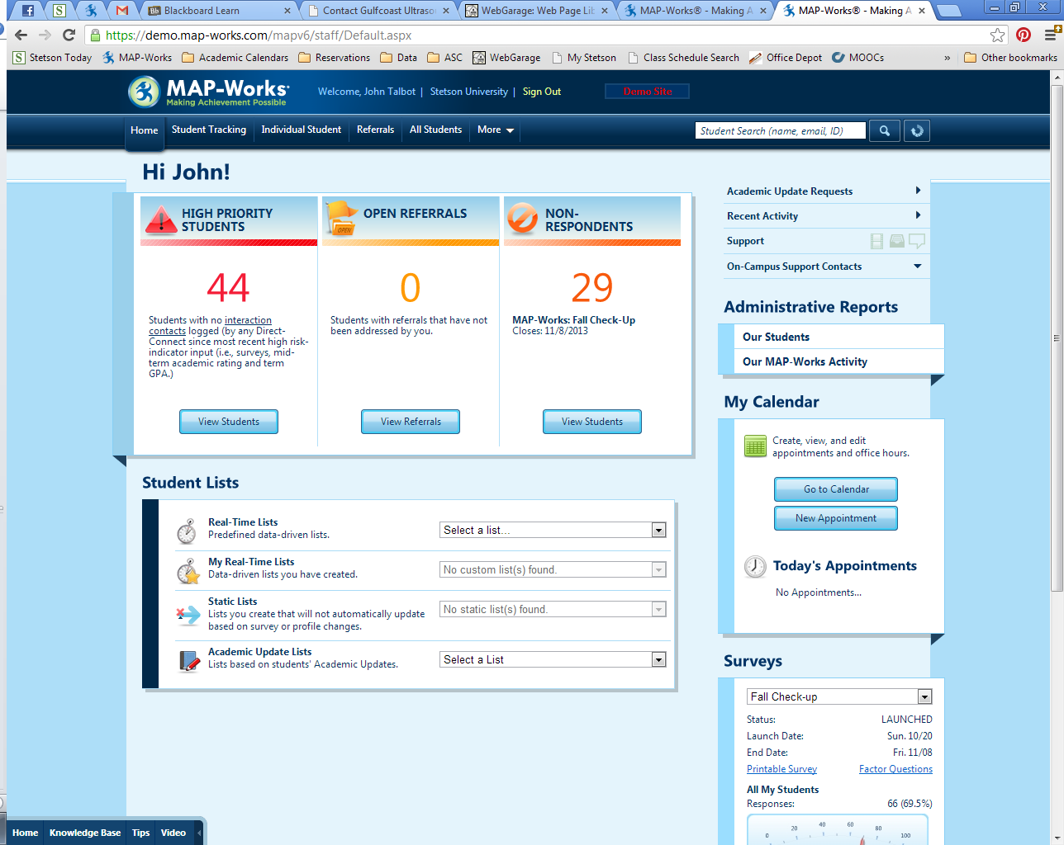

Academic Updates
This function allows faculty (and only faculty) to provide information about how students are performing in their courses. You can submit academic updates as often as you like, on as many or as few students as you like. Sometimes, Student Success may request updates on students—for instance, we use MAP-Works to request updates for student athletes. If an Academic Update is requested, you will receive an email prompting you to log into MAP-Works to complete the request
Input Only users will see two places on their home page to access Academic Updates
Direct Connect users will see the link to Academic Updates on the right-hand side of their home page.

Accessing Academic Updates - Requested
If a request is sent, you will receive an email asking you to log into MAP-Works to complete the request. Your home page will indicate there is a pending request for academic updates.
When you select the link, you will automatically be brought to your Pending Update Requests page, which only lists the students for whom updates have been requested in each class you are teaching.

Accessing Academic Updates - General
If an Academic Update has not been requested, when you select one of the links indicated above you will be brought to the page below. You can also select Enter Academic Updates from the Pending Update Request page.
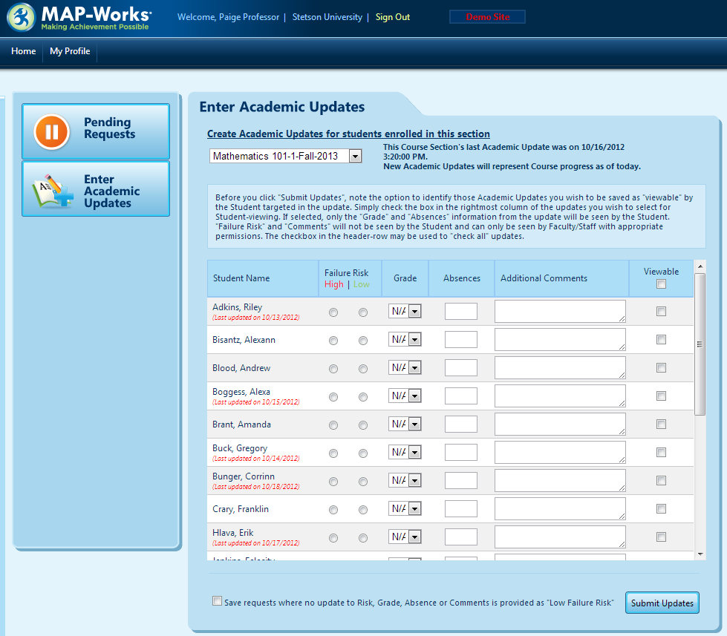

Submitting Academic Updates
Whether requested or not, Academic Updates submission is essentially the same. The top of the page has a drop-down menu listing your classes. Select a class, and you will see a list of students below. Let’s review the different columns
Student Name: Last and first name of your students, as well as a note of the last date you submitted an update.
Failure Risk: You can indicate whether the student is at high or low risk of failure.
Grade: An estimate of the student’s grade to date.
Absences: Numbers only. We ask that you report the total absences to date, thus successive updates will show an increased number of absences if the student has been absent.
Additional Comments: An open field for you to submit comments on the student.
Viewable: As noted on the page, if you check this box, the student will be able to see the Grade and Absences you submit in the update.
At the bottom of the page is an option to “Save requests where no update to Risk, Grade, Absence or Comments is provided as ‘Low Failure Risk’”. For instance, suppose you had entered updated on 3 students. Selecting this box will also submit updates for the other students in the course, with the only content being “Low Failure Risk”.

Frequently Asked Questions about Academic Updates
Q: Who sees Academic Updates?
A: Only faculty and staff with Direct-Connect access who are connected to the student will see the Academic Update. This might include the student’s faculty for the semester, department chairs, Dean-level staff, Student Success, and group-bound staff (e.g., Assistant Director for Fraternity and Sorority Involvement has access to Greek students, International Learning staff have access to international students).
Q: What is done with the information?
A: This answer is two-fold. 1) Student Success monitors Academic Updates for all students, doing outreach about absences and academic performance. 2) The MAP-Works system calculates student risk based on all the information submitted into the system. Academic Updates factor into a student’s risk indicator—the more information we have, the more refined the indicator becomes.
Q: Should I submit concerns about cheating in an Academic Update?
A: Not necessarily. While Academic Updates are checked regularly to gauge needed intervention, and cheating is academic in nature, your concern should be reported to the Honor Council; please see their website for more details, http://www.stetson.edu/other/honor-system/reporting.php.
Q: Can I submit concerns about Student Code of Community Standards violations in Academic Updates?
A: Again, focus on the academic nature of your updates. If you want to report a violation of the Student Code of Community Standards, you can submit an incident report at http://www.stetson.edy/reportit. This form can be submitted anonymously, however the more information you provide the better we can investigate the report.
If you have more questions, please contact Student Success at studentsuccess@stetson.edu

Referrals
Faculty can also submit referrals to the MAP-Works system. Referrals can be sent to several offices on campus as well as faculty staff connected to the student. Again, accessing referrals looks a little different whether you are an Input Only user or Direct-Connect user. Currently, Faculty are not set to receive referrals, only issue them.

Accessing Referrals
Input only faculty will see student Referrals as on option on their homepage
Selecting Go for the Student Referrals will bring up a box where you can select a student for whom you will issue a referral. You can start typing a student name or ID and possible student matches will appear.

Direct-Connect faculty will see Referrals as a menu option at the top of their pages
The menu will bring you to the Manage Referrals page where you can see open referrals assigned to you* and Issue Referrals. Selecting Issue Referral will bring up a box where you can select a student for whom you will issue a referral. You can start typing a student name or ID and possible student matches will appear (pictured above). (*Faculty are not set to be able to receive referrals at this time)

Issuing a Referral
Once a student is selected, you will have a referral open for submission.
Your comment should explain the nature of the referral. Please only disclose details you are comfortable with others seeing.
Primary Category: Several category choices are presented; pick the best fit for your referral.
Assign to: Your options might very here. Input Only faculty will be able to refer to several offices on campus (Central Contacts) while Direct-Connect Faculty may have additional options to refer to the student’s other Direct-Connects. You can also choose “Your campus’ Central Referral Coordinator” if you do not know to whom to assign the referral.
Interested Parties: Direct-connect faculty can also flag other faculty and staff that might need a heads up about the referral. These interested parties are notified of the referral, but do not need to respond.
Answer the questions to the best of your ability. We highly encourage openness in referrals, so whenever possible discuss the referral with the student and consider allowing us to reveal who sent in a referral.
Sharing: Again, openness and sharing is part of what makes MAP-Works effective. As often as possible, mark your referral Public (check the FAQs for a definition).

Frequently Asked Questions about Referrals
Q: Public!? Who is going to see this?
A: Public does not mean everyone can see this information. Public means that the Direct-Connect users connected to the student have access to see the information. We want Direct-Connects to see this information so we can all be better informed as we work with students.
Q: Do I need to do a referral instead of calling?
A: If you have a situation you would rather call us about, by all means do. It is possible we may ask you to go back to create a referral just to have it in the system, but we understand that sometimes it is best to talk directly with a person.
Q: How will I know if my referral has been addressed?
A: In many cases, we will notify you of the outreach we do in response to a referral and work together to guide our students. In some cases this cannot be done—for instance, referrals to the Counseling Center will be closed once seen and further information to the faculty will only come at the request of the student since the Counseling Center is bound by confidentiality. In any case, once a referral is closed in MAP-Works, you will receive an automated email.
Q: Can our department administrative assistant submit referrals for me?
A: Not quite. If your department determines that the administrative assistant needs access to MAP-Works, please contact Student Success about setting up access. Referrals will be tied to the actual sender, so while an administrative assistant would be able to send a referral after gaining access, the best that could be done is to have faculty tied to the referral as an Interested Party.

Resources for Students & Advisors

Student Profile
As a Direct-Connect user, you have access to view profiles on your students. The main information on the profile page will show the student’s name, picture, cohort, student ID, campus address, email, phone, self-reported intend to leave, and the Risk Indicator (Please note: currently, MAP-Works only calculates a global risk indicator for First-Year and Sophomore students; as the company collects and validates more national data on Junior and Senior students, they may introduce a risk indicator in for these cohorts in the future.). There is also a feature to mark as Reviewed; this feature is unique to each faculty/staff user—it will indicate your last day of review, and no other users see your reviewed information. Use of this feature is optional.
The rest of the student profile is contained within four tabs: Talking Points, About the Student, Activity, and Survey/Dashboard. We will look at each.

Talking Points
This tab presents highlights about the student, like recent activity and a survey summary. A useful part are the weaknesses and strengths presented based on the student’s survey responses

About the Student
This tab presents much of the information that is uploaded into MAP-Works from Banner.
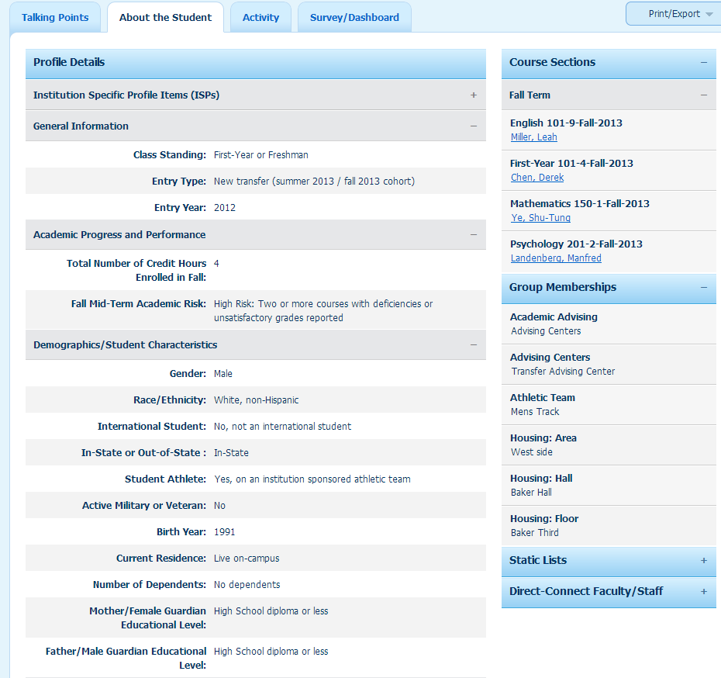
Continued on next page

In particular, please note the list of Direct-Connect Faculty/Staff. This drop-down menu displays all the faculty and staff who are connected to a particular student based on course connections or groups. You may notice some duplicate names; faculty/staff who are connected to multiple levels of a particular group hierarchy will be displayed more than once.
Students can be assigned a Primary Direct-Connect, who will appear at the top of this listing of Direct-Connect Faculty/Staff. The Primary Direct-Connect is a staff member designated to be the front-line outreach person for that student. Thus, the Primary Direct-Connect, in cooperation with Student Success, will respond to concerns in MAP-Works—you, as faculty, do not need to be responsible for following up with students based on a troublesome Risk Indicator or concerning Academic updates, but we do believe it is good information for you to know.

Activity
This tab is part of what is great in MAP-Works. Here you will see the activity logged for a student by other faculty and staff users, including contacts, notes, referrals, academic updates, and student tasks. Don’t worry, each of these activities has options for sharing Public (all faculty/staff connected to the student) or in pre-determined teams. So, you may see an activity logged by staff in the Academic Success Center saying they met with the student to discuss time management and studying. What you will not see is the note logged by that same staff person that has more details about that meeting, which was only shared with the ASC Team.
Again, we encourage faculty and staff to input information that can be public, as it is this increased communication that makes MAP-Works so useful. Your activities can be edited if you feel like some information shouldn’t be shared so widely, and faculty can make referrals that are shared privately, if needed.
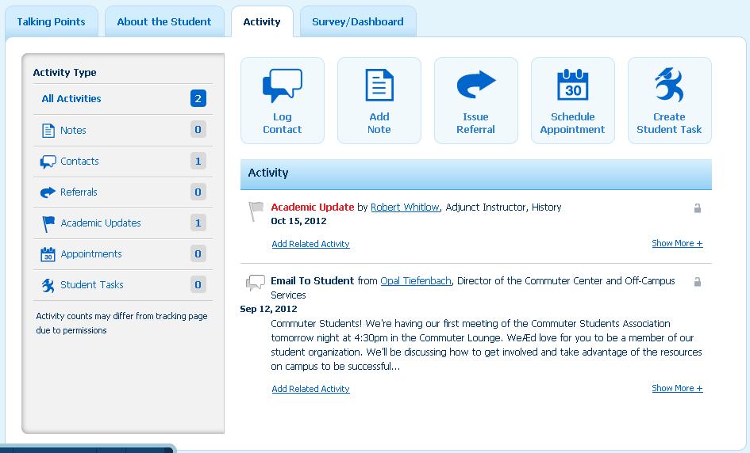

Survey Dashboard
This final area of the student profile has the other half of the magic involved in MAP-Works: student survey data. For students who have completed the surveys, you will see a breakdown of their survey rating by the factors in the survey. This is a wonderful resource when meeting with students, as you get an idea of where they are in many dimensions. Factors include:
Academics
Behaviors & Activities
Socio-Emotional
Financial Means
Performance & Expectations
Special Topic Modules
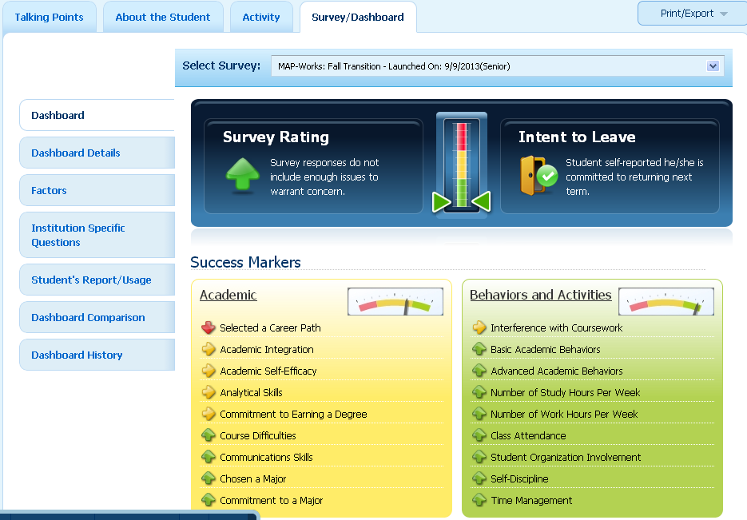
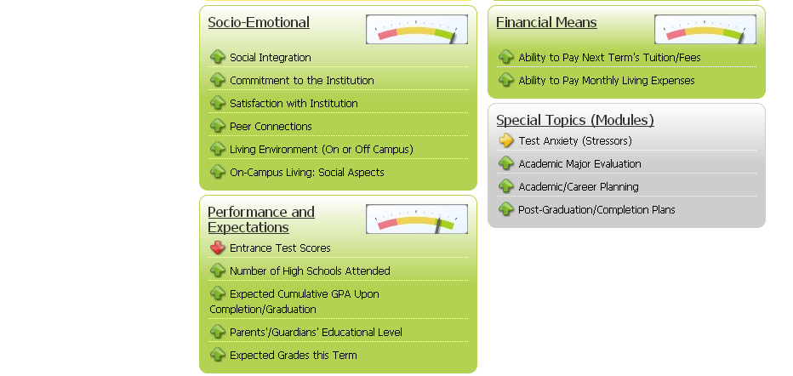

On the Student’s Report/Usage potion of this tab, you can also download the student’s personalized student report, which they have access to as soon as complete the survey. We recommend using the student report in meetings with students, as it can be a great exercise to go through the report together.
Download the student’s report, and you can even access the student’s portal to show them how to access their report independently.
